Machine Learning-Based Cardiovascular Disease Risk Prediction with External Validation on Bangladeshi Data

Abstract
Cardiovascular disease (CVD) is the leading cause of death worldwide, but most risk models are built on Western populations and are rarely tested on Bangladeshi patients. This study trained machine-learning (ML) models on three general CVD datasets and tested them on an unseen Bangladeshi (BD) dataset. The three development datasets were Dataset A (253,661 records), Dataset B, Framingham (4,240 records), and Dataset C (69,976 records). They were harmonised into one dataset of 327,877 records (18.15% CVD) with eight shared predictors: age, sex, BMI, systolic and diastolic blood pressure, total cholesterol, smoking, diabetes and physical activity. All records were retained and divided by a group-aware stratified split into training (229,513), validation (49,174) and test (49,190) sets. Eight individual models were tuned by grouped five-fold cross-validation on the training set: Random Forest, Extra Trees, XGBoost, LightGBM, K-Nearest Neighbours, Logistic Regression, a Neural Network (MLP) and an RBF-kernel SVM. A ninth Classifier Model stacked the eight through a logistic-regression meta-learner, and decision thresholds were fixed on the validation set with Youden’s J statistical model. The BD dataset (1,529 patients, 25.18% CVD) was never used for training, tuning, threshold selection or any fitting. On this unseen data, three predictions were compared: the Classifier Model, a frontier model and a domain expert. Three areas were then analysed: performance (accuracy, precision, recall and F1-score), patient-level explainability (SHAP and LIME), and outcome uncertainty (Gini impurity and entropy).
On the held-out test set, LightGBM was the best individual model, with the highest accuracy (0.775), precision (0.431) and F1-score (0.550) and a recall of 0.759; Extra Trees had the highest recall (0.786). The Classifier Model reached an accuracy of 0.771, precision of 0.426, recall of 0.765 and F1-score of 0.548, matching LightGBM to within 0.005 but not exceeding it. On the unseen BD data, the Classifier Model achieved an accuracy of 0.653, precision of 0.376, recall of 0.569 and F1-score of 0.453. XGBoost recorded the highest BD accuracy (0.690) and precision (0.403), the SVM the highest recall (0.813) and Extra Trees the highest F1-score (0.476). Logistic Regression was the most stable, with accuracy changing by only 0.010. The frontier model achieved an accuracy of [DATA REQUIRED], precision of [DATA REQUIRED], recall of [DATA REQUIRED] and F1-score of [DATA REQUIRED]. The domain experts achieved an accuracy of [DATA REQUIRED], precision of [DATA REQUIRED], recall of [DATA REQUIRED] and F1-score of [DATA REQUIRED]. The lower BD performance coincided with measurable differences in age, diabetes, smoking, prevalence and the age–CVD relationship.
The entropy and impurity analysis showed that the training outcome (Gini 0.297, entropy 0.683 bits) was less uncertain than the BD outcome (Gini 0.377, entropy 0.814 bits). The tree-based models removed about 35–37% of this impurity, and blood pressure accounted for 56–68% of the impurity or loss reduction. Exact SHAP values for all 1,529 BD patients ranked systolic BP (25.2%), diastolic BP (21.6%) and age (18.7%) highest. SHAP and LIME agreed on the most influential feature for 38.7% of patients. Evidence on ML CVD models in Bangladeshi populations is limited, and many studies compare few model families, rely on a single summary metric, explain only a few predictions, and do not report the effects of merging heterogeneous datasets. This study addresses these gaps with a reproducible, leakage-controlled comparison of nine models on unseen Bangladeshi data, evaluated mainly by accuracy, precision, recall and F1-score, with patient-level explanations and a documented analysis of dataset representation differences.

1. Introduction

1.1 Background
Cardiovascular disease remains the largest single cause of death and disability worldwide, and its burden has continued to rise with population growth and ageing (Roth et al., 2020). Most CVD events are linked to a small set of modifiable risk factors such as hypertension, dyslipidaemia, diabetes and smoking (Yusuf et al., 2004). Identifying people at elevated risk before an event occurs therefore allows earlier lifestyle and pharmacological intervention.
Clinical practice has long relied on regression-based risk scores, notably the Framingham general CVD profile (D'Agostino et al., 2008), QRISK3 (Hippisley-Cox et al., 2017) and the World Health Organization risk charts (WHO CVD Risk Chart Working Group, 2019). Machine learning (ML) offers an alternative that can model non-linear effects and interactions without specifying them in advance. Studies on large cohorts have reported that ML models can match or exceed conventional scores (Weng et al., 2017; Alaa et al., 2019), and a meta-analysis found promising discrimination for boosting and support vector machine methods (Krittanawong et al., 2020).
These advantages come with challenges. Gains over well-specified logistic regression are not guaranteed (Christodoulou et al., 2019), complex models are harder to interpret (Rudin, 2019), and performance measured on the development population often fails to transfer to new settings (Futoma et al., 2020).

1.2 Problem Statement
CVD risk models are mostly developed on North American and European populations. South Asians develop CVD earlier and with a different risk-factor profile (Joshi et al., 2007; Volgman et al., 2018), and Bangladesh has a high and rising prevalence of these risk factors (Fatema et al., 2016). Few studies have trained ML models on large datasets and then tested them, without any refitting, on Bangladeshi patients. It is therefore unclear how well such models transfer, which model families transfer best, and how their accuracy, precision, recall and F1-score change.

1.3 Motivation
Routine variables such as blood pressure, cholesterol and BMI are widely available even in resource-limited settings. A model that uses only these variables, explains each prediction and has been tested on local patients could support screening in Bangladesh. Measuring how much performance changes on an external population is also necessary before any such tool can be considered for practice (Steyerberg & Vergouwe, 2014).

1.4 Research Objectives
- To harmonise three heterogeneous CVD datasets into one development dataset with a shared set of eight predictors.
- To train and tune eight individual ML models and a ninth stacked Classifier Model while preventing data leakage.
- To evaluate all nine models on a held-out test set, mainly by accuracy, precision, recall and F1-score.
- To evaluate the unchanged models on an unseen Bangladeshi dataset and analyse the change in performance.
- To provide patient-level SHAP and LIME explanations for every prediction.
- To quantify, with Gini impurity and entropy, how much outcome uncertainty the tree-based models removed and which predictors removed it.

2. Literature Review

2.1 Traditional CVD Risk Prediction
Modern CVD risk prediction grew out of prospective cohorts, beginning with the Framingham Heart Study (Dawber et al., 1951). Its general CVD risk profile combined age, sex, cholesterol, blood pressure, smoking and diabetes in a sex-specific Cox model (D'Agostino et al., 2008). QRISK3 extended this approach with additional clinical conditions in a large UK primary-care cohort (Hippisley-Cox et al., 2017). The WHO recalibrated risk charts for 21 global regions to address differences in baseline risk between populations (WHO CVD Risk Chart Working Group, 2019). These tools are transparent and well validated, but they assume largely additive effects and are calibrated to the populations that produced them.
The INTERHEART study showed that a common set of modifiable factors explains most myocardial-infarction risk across 52 countries (Yusuf et al., 2004). The variables used in the present study (blood pressure, cholesterol, diabetes, smoking, BMI, physical activity, age and sex) are drawn from this established set.

2.2 Classical Machine Learning
Logistic regression remains the reference method in clinical prediction. A systematic review of 71 comparisons found no average performance benefit of ML over logistic regression when the risk of bias was low (Christodoulou et al., 2019). Support vector machines separate classes with a maximum-margin boundary and, with a Gaussian kernel, can model non-linear structure (Cortes & Vapnik, 1995); their decision values are commonly converted to probabilities with Platt scaling (Platt, 1999). The k-nearest-neighbour rule classifies a case by its closest training examples (Cover & Hart, 1967) and is sensitive to feature scaling and to the density of similar cases. Hybrid combinations of such classifiers have also been reported for heart-disease prediction (Mohan et al., 2019).

2.3 Tree-Based Ensemble Models
Random forests average many decorrelated decision trees grown on bootstrap samples (Breiman, 2001). Extremely randomised trees go further by choosing split thresholds at random, which reduces variance (Geurts et al., 2006). Gradient boosting builds trees sequentially to correct earlier errors; XGBoost introduced regularised, scalable boosting (Chen & Guestrin, 2016) and LightGBM added histogram-based, leaf-wise growth for speed on large data (Ke et al., 2017). In cardiovascular cohorts, tree ensembles and random survival forests have improved on conventional scores in several studies (Ambale-Venkatesh et al., 2017; Kakadiaris et al., 2018; Weng et al., 2017), and boosting was among the strongest families in a meta-analysis (Krittanawong et al., 2020).

2.4 Neural Networks
Multilayer perceptrons trained by back-propagation learn non-linear functions of their inputs (Rumelhart et al., 1986). In the UK Biobank, an automated ML framework that included neural models predicted CVD better than the Framingham score (Alaa et al., 2019). Neural networks, however, require careful regularisation and can extrapolate unpredictably outside the range of their training data.

2.5 Ensemble and Stacking Methods
Stacked generalisation trains a meta-learner on the outputs of several base models so that their errors can partly cancel (Wolpert, 1992). Stacking requires that the meta-learner is fitted on predictions the base models did not produce from their own training data; otherwise it learns from over-optimistic inputs. Combining diverse model families is a common route to more stable predictions in heart-disease studies (Mohan et al., 2019).

2.6 Explainable AI in Healthcare
Opaque models are difficult to trust in high-stakes decisions, and some authors argue for inherently interpretable models where possible (Rudin, 2019). SHAP attributes each prediction to its features using Shapley values from cooperative game theory and satisfies local accuracy and consistency (Lundberg & Lee, 2017). Fast exact algorithms exist for tree models (Lundberg et al., 2020). LIME instead fits a simple local surrogate around each prediction (Ribeiro et al., 2016). Using both offers two different views of the same prediction.

2.7 External Validation, Generalisation and Evaluation
Reporting guidance for prediction models stresses that internal performance overestimates performance in new settings and that external validation is essential (Collins et al., 2015; Steyerberg & Vergouwe, 2014). Dataset shift, in the form of covariate shift, prior-probability shift or concept shift, explains many failures of transfer (Moreno-Torres et al., 2012), and ML models in health care often fail to generalise across sites (Futoma et al., 2020). Calibration should be checked alongside discrimination (Van Calster et al., 2019).
On imbalanced outcomes, accuracy alone can mislead, and precision–recall-based measures are more informative (He & Garcia, 2009; Saito & Rehmsmeier, 2015). The Matthews correlation coefficient summarises all four confusion-matrix cells (Chicco & Jurman, 2020). Youden's J statistic is a standard way to choose a decision threshold that balances sensitivity and specificity (Youden, 1950).

2.8 South Asian and Bangladeshi CVD Research
South Asians experience first myocardial infarction at younger ages, with a higher burden of risk factors at presentation (Joshi et al., 2007), and show distinct patterns of atherosclerotic disease (Volgman et al., 2018). In Bangladesh, coronary artery disease has become a leading cause of death (Islam & Majumder, 2013), and the prevalence of diabetes, hypertension, dyslipidaemia and smoking is high, particularly in urban areas (Fatema et al., 2016). The WHO regional charts provide recalibrated estimates for South Asia but are not ML models (WHO CVD Risk Chart Working Group, 2019).

2.9 Limitations of Existing Research
Three gaps recur across the reviewed work. First, many ML studies evaluate models only on a random split of their development data, without external validation (Collins et al., 2015; Futoma et al., 2020). Second, evidence on how ML risk models trained on Western data perform in Bangladeshi populations is limited (Fatema et al., 2016; Islam & Majumder, 2013). Third, many studies report a single summary metric, most often ROC-AUC (Krittanawong et al., 2020), rather than the full accuracy, precision, recall and F1 profile and its precision–recall trade-off (Saito & Rehmsmeier, 2015).

3. Methodology

3.1 Research Design
The study is a retrospective model-development and external-validation study. Three datasets formed the development data; a separate Bangladeshi dataset was reserved for final external testing. All modelling was implemented in Python with scikit-learn (Pedregosa et al., 2011), XGBoost, LightGBM, SHAP and LIME, and run on Kaggle. The saved models record scikit-learn version 1.6.1, and the BD evaluation was run in the same environment.

3.2 Dataset Description
Dataset | File used | Records | Outcome column | CVD prevalence | Role
A | heart_disease_health_indicators_age_in_years.csv | 253,661 | HeartDiseaseorAttack (0/1) | 9.42% | Development
B (Framingham) | framingham_imputed.csv | 4,240 | CVD_risk_level (High/Low; 644 High) | 15.19% | Development
C | clean_dataset_5_imputed.csv | 69,976 | target (0/1) | 49.98% | Development
BD (BD_2025) | BD_2025 Final Dataset tuned and without actual prediction.csv | 1,529 | CVD Prediction (Yes/No), in the separate file with actual labels | 25.18% | Unseen external test
All four files shared, after harmonisation, eight predictors: age (years), sex, BMI, blood pressure (systolic/diastolic, mmHg), total cholesterol (mg/dL), smoking, diabetes and physical activity. The supplied development files contained no missing values; they were supplied in an already-processed form (Section 3.5). The BD file also contained no missing values.
Characteristic | Development data (merged) | BD data
Records | 327,877 | 1,529
Mean age (years) | 56.4 | 47.0
Male | 42.1% | 49.4%
Mean BMI | 28.2 | 28.5
Mean systolic / diastolic BP (mmHg) | 123.1 / 79.2 | 125.5 / 83.0
Mean total cholesterol (mg/dL), SD | 189.7, SD 26.6 | 198.6, SD 56.4
Smoking | 36.8% | 51.6%
Diabetes | 13.9% | 50.8%
Physically active | 76.8% | 67.6%
CVD | 18.1% | 25.2%
The outcome columns of the three development sources (HeartDiseaseorAttack, CVD_risk_level and target) were combined into one binary label: CVD = 1, no CVD = 0.

3.3 Training and Testing Strategy
The merged development dataset was split once, before any fitting, into training (70%), validation (15%) and test (15%) sets, stratified by outcome with a fixed random seed (42). The split was group-aware: records with identical predictor values were assigned to the same set, so that no identical record could appear in both training and test data.
Set | Records | CVD prevalence | Used for
Training | 229,513 | 18.15% | Fitting imputers, scalers and all eight models; hyperparameter cross-validation
Validation | 49,174 | 18.16% | Decision thresholds; choosing and fitting the Classifier Model
Test | 49,190 | 18.14% | Final internal evaluation, used once
BD | 1,529 | 25.18% | Final external evaluation, used once

3.4 Data Preprocessing
- Encoding. Sex was coded 1 = male, 0 = female. Smoking, diabetes and physical activity were coded 1 = yes, 0 = no. In Dataset A, diabetes was recorded as 0, 1 and 2; following the study's decision, both 1 and 2 were coded as 1.
- Blood pressure. Blood pressure was stored as a "systolic/diastolic" string and split into two numeric features inside each model pipeline.
- Record retention. No records were removed: no plausibility filters, outlier removal or de-duplication were applied, so all 327,877 development records were kept.
- Imputation. Inside each pipeline, missing continuous values were filled with the training-set median and missing binary values with the training-set mode.
- Scaling. Standardisation (z-scores) was applied for the SVM, KNN, Logistic Regression and Neural Network, fitted on the training set only.
- Feature order. The nine model features were age, BMI, systolic BP, diastolic BP, total cholesterol, sex, smoking, diabetes and physical activity.
For the BD data, five column names were mapped to the training schema (for example, "Blood Pressure (mmHg)" to blood_pressure). Text categories were converted to the training encoding: Sex F/M to 0/1, Smoking and Diabetes Y/N to 0/1, and Physical Activity Level High or Moderate to 1 and Low to 0. The last mapping is a study decision, because the training data recorded physical activity only as yes/no. No statistic was computed from BD data.

3.5 Cholesterol and Blood-Pressure Data Harmonization
All four sources supplied total cholesterol in mg/dL and blood pressure as systolic/diastolic readings, but the values differed in range, spread and granularity.
- Dataset A: cholesterol 120–288 mg/dL (159 distinct values, SD 23.5); systolic BP SD 14.0 mmHg (81 distinct values).
- Dataset B: cholesterol 107–696 mg/dL (249 distinct values, SD 44.3); systolic BP SD 22.0 mmHg (234 distinct values).
- Dataset C: cholesterol 140–294 mg/dL (155 distinct values, SD 32.3); systolic BP SD 16.6 mmHg (108 distinct values).
- BD dataset: cholesterol 100–300 mg/dL (201 distinct values, SD 56.4); systolic BP SD 22.0 mmHg (90 distinct values).
The difference mattered because the models learn numeric split points from the development distribution, which is 77% Dataset A. The much wider BD spread places many BD patients in value ranges represented mainly by the small Dataset B.
Harmonisation in this study used the common mg/dL and mmHg columns as supplied, split blood pressure into systolic and diastolic values inside each model pipeline, and filled any missing value with the training-set median. Two development files carry "imputed" in their names (framingham_imputed.csv and clean_dataset_5_imputed.csv). How their cholesterol and blood-pressure values were produced before this study: [FINAL IMPLEMENTATION DETAIL REQUIRED].
This approach does not correct differences in spread between sources. During data auditing, Dataset A's cholesterol alone separated the outcome more strongly (single-feature ROC-AUC 0.673) than cholesterol in the other sources (0.56–0.60), and the reason could not be determined from the files. A possible impact is that cholesterol relationships learned mainly from Dataset A transfer less well to BD values.

3.6 The Eight Individual Models
Hyperparameters were selected by cross-validation (Section 3.9). The final values below are read from the saved model files.
Model | Principle | Final hyperparameters
Random Forest | Averages bootstrap-trained decision trees with random feature subsets (Breiman, 2001) | 300 trees, max depth 14, min samples per leaf 5, max features log2, Gini criterion, bootstrap
Extra Trees | Averages trees with randomly drawn split thresholds (Geurts et al., 2006) | 500 trees, max depth 24, min samples per leaf 10, all features per split, Gini criterion, no bootstrap
XGBoost | Regularised gradient boosting of trees (Chen & Guestrin, 2016) | 558 trees, learning rate 0.010, max depth 7, min child weight 13.18, subsample 0.79, column sample 0.71, L2 1.69, L1 0.004, gamma 1.30
LightGBM | Histogram-based, leaf-wise gradient boosting (Ke et al., 2017) | 452 trees, learning rate 0.017, 122 leaves, max depth 12, min child samples 41, subsample 0.76, column sample 0.67, L2 0.18, L1 0.001
K-Nearest Neighbours | Classifies by the closest training cases (Cover & Hart, 1967) | k = 101, distance weighting, Euclidean distance, standardised features
Logistic Regression | Linear model of the log-odds | L2 penalty, C = 0.001, lbfgs solver, standardised features
Neural Network (MLP) | Feed-forward network trained by back-propagation (Rumelhart et al., 1986) | Hidden layers 128 and 64, ReLU, alpha 0.0028, learning rate 0.0089, batch 512, early stopping (stopped after 22 epochs), standardised features
SVM (Gaussian/RBF kernel) | Maximum-margin classifier with a Gaussian kernel (Cortes & Vapnik, 1995) | C = 1, gamma = 0.01, standardised features; trained on all training rows in three chunks (below)
An exact RBF-SVM on 229,513 rows exceeded the available session time. The training rows were therefore split into three stratified chunks of 76,504–76,505 rows, and one exact SVM was trained on each, so that every training row was used. The three SVMs had 27,391, 27,545 and 27,498 support vectors. Each was calibrated with Platt scaling on the two chunks it had not seen (Platt, 1999), and their probabilities were averaged.
Tree models offer non-linear interactions with little preprocessing. Logistic Regression is the clinical reference. KNN and the SVM represent distance- and kernel-based learning, and the MLP represents neural learning. This range was chosen so that model families with different inductive biases could be compared.

3.7 The Classifier Model (Ninth Model)
The Classifier Model combines the probability outputs of the eight individual models.
- Each individual model was trained on the training set and produced probabilities for the validation set, which it had not seen.
- Three combination methods were compared by grouped five-fold cross-validation within the validation set: a simple average, a weighted average with weights fitted by log-loss, and stacking with a logistic-regression meta-learner on the logit of each model's probability. Selection used mean cross-validated ROC-AUC, with out-of-fold log-loss as a tie-breaker.
- Stacking was selected and refitted on the whole validation set.
- The decision threshold (0.1908) was set by Youden's J on the out-of-fold validation probabilities.
The learned meta-learner coefficients were: LightGBM 1.093, Random Forest 0.147, MLP 0.057, SVM 0.018, Extra Trees 0.007, KNN −0.009, Logistic Regression −0.051 and XGBoost −0.224 (intercept 0.034). The cross-validation scores of the three candidate methods: [DATA REQUIRED].
Because the meta-learner was fitted only on validation-set predictions from models trained on the training set, its inputs were never produced from the data it was learning from. The test and BD sets played no part in building it. At prediction time, a patient's features pass through each model's own preprocessing and classifier; the eight probabilities are combined by the meta-learner, and the result is compared with 0.1908.

3.8 Dataset Dominance
Dataset A contains about 3.6 times as many records as Dataset C and 60 times as many as Dataset B. A dataset-balanced, stratified down-sampling strategy was explored during data preparation. The final methodology did not use it: all records from all three datasets were retained without sampling or weighting. In the final development data, Dataset A contributes 77.36% of records, Dataset C 21.34% and Dataset B 1.29%. No procedure was applied to prevent Dataset A from dominating training, and the consequences are discussed in Sections 4.3 and 7.

3.9 Cross-Validation
Hyperparameters were tuned by stratified, group-aware five-fold cross-validation inside the training set only. Records with identical predictor values were kept in the same fold.
Model | Search | Candidates | Tuning rows
Random Forest, Extra Trees | Random search | 12 | 60,000 (stratified sample of training set)
XGBoost, LightGBM | Random search | 25 | 60,000
Neural Network | Random search | 10 | 60,000
KNN | Grid search | 14 | 60,000
SVM | Grid search | 48 (8 C × 6 gamma) | 20,000
Logistic Regression | Grid search | 12 values of C | All 229,513 training rows
The tuning objective was ROC-AUC. After tuning, every final model was refitted on all 229,513 training rows. The best cross-validated score for each model: [DATA REQUIRED]. The BD dataset was not involved in cross-validation.

3.10 Decision Thresholds and Performance Evaluation
Because CVD prevalence was 18%, a 0.5 cut-off would label very few patients as CVD. For each individual model, the threshold was chosen on the validation set by Youden's J (Youden, 1950). The resulting thresholds were 0.1860 (Extra Trees), 0.1854 (XGBoost), 0.1990 (LightGBM), 0.1674 (SVM), 0.1909 (Random Forest), 0.1777 (KNN), 0.1533 (Logistic Regression), 0.1814 (MLP) and 0.1908 (Classifier Model). A patient is classified as CVD when the predicted probability is at or above the threshold. The test set and the BD set were each evaluated once with these fixed thresholds.

3.11 Performance Metrics
Accuracy, Precision, Recall and F1-score are the primary metrics of this report. With TP, TN, FP and FN denoting true positives, true negatives, false positives and false negatives:
- Accuracy = (TP + TN) / (TP + TN + FP + FN): the proportion of correctly classified patients.
- Precision = TP / (TP + FP): the proportion of patients predicted as CVD who actually had CVD.
- Recall (sensitivity) = TP / (TP + FN): the proportion of actual CVD patients identified.
- F1-score = 2 × Precision × Recall / (Precision + Recall): the harmonic mean of precision and recall.
Secondary metrics are specificity, TN / (TN + FP); balanced accuracy, the mean of recall and specificity; the Matthews correlation coefficient (MCC) (Chicco & Jurman, 2020); and ROC-AUC, which is threshold-free and reported for reference only.

3.12 Explainability
Every prediction of the Classifier Model was explained in two ways.
- SHAP. Exact SHAP values were computed by evaluating all 2^9 = 512 feature coalitions against a reference patient defined by the training-set median or mode of each feature (Lundberg & Lee, 2017). A check against the SHAP library's exact explainer agreed to within 4.4 × 10^-16, and the values summed exactly to each patient's predicted risk minus the reference risk.
- LIME. A local linear surrogate was fitted around each patient from 500 perturbed samples, with 5,000 training records as the sampling background (Ribeiro et al., 2016).
The explanation background and reference patient came from the training set only. Because computing explanations for 327,877 records exceeded one session, the work was divided into chunks and merged by record. Confirmation that the final merged development explanation file covers all 327,877 records: [DATA REQUIRED]. Explanations were completed for all 1,529 BD patients.
For the BD dataset, the per-patient SHAP values were summarised as global importance (mean absolute SHAP value), a beeswarm plot, importance by predicted class, the most influential feature per patient and dependence plots. LIME weights were taken from the three factors per direction listed in each patient's explanation and summarised in the same way. Four example patients were selected by rule: the highest predicted risk, the lowest risk still at or above the threshold, the highest risk still below the threshold, and the lowest predicted risk. In addition, an entropy and impurity analysis of the four tree-based models was carried out (Section 3.13).

3.13 Entropy and Impurity Analysis
To describe how the tree-based models reduce uncertainty about the outcome, Gini impurity and entropy were calculated from the saved, trained models. For any group of patients (a node of a tree), let p be the proportion with CVD (Yes) and 1 − p the proportion without CVD (No).
Gini(p) = 1 − p² − (1 − p)² (1)
H(p) = −p·log₂(p) − (1 − p)·log₂(1 − p) [bits] (2)
Both measures are 0 when a node contains only one class and are largest when p = 0.5 (Gini 0.5, entropy 1 bit). Entropy in natural-log units (nats) equals the value in bits multiplied by ln 2.
Split. When a node with N patients is divided into a left child (n_L patients) and a right child (n_R patients), the reduction in impurity is:
ΔGini = Gini(parent) − (n_L/N)·Gini(left) − (n_R/N)·Gini(right) (3)
Information gain = H(parent) − (n_L/N)·H(left) − (n_R/N)·H(right) (4)
Whole tree. The impurity remaining after a tree is the size-weighted average over its final nodes (leaves), and the reduction is expressed relative to the root node. The same is done for entropy.
Leaf-weighted Gini = Σ over leaves (n_leaf/N)·Gini(leaf) (5)
Reduction (%) = 100 × (1 − leaf-weighted Gini / root Gini) (6)
Feature importance. Each split's reduction, weighted by the share of patients reaching that node, was credited to the feature used, divided by the total over all splits, and averaged over the trees of the model:
Importance(f) = Σ over splits on f (n_node/N)·ΔGini ÷ Σ over all splits (n_node/N)·ΔGini (7)
Using ΔGini gives the Gini importance (mean decrease in impurity); using the information gain gives the entropy importance.
Random Forest and Extra Trees were trained with the Gini criterion; entropy was calculated afterwards from the same class counts stored in each node, so the models were not changed. For Random Forest, node counts include the repeated rows of each tree's bootstrap sample; Extra Trees uses no bootstrap, so its root node equals the full training set.
Boosted trees. XGBoost and LightGBM nodes do not store class proportions. Their impurity is the binary log loss (cross-entropy). With predicted probability pᵢ and label yᵢ (1 = CVD, 0 = no CVD) for patient i:
Log loss = −Σᵢ [ yᵢ·ln(pᵢ) + (1 − yᵢ)·ln(1 − pᵢ) ] (8)
gᵢ = pᵢ − yᵢ , hᵢ = pᵢ(1 − pᵢ) , G = Σ gᵢ , H = Σ hᵢ (hessian cover) (9)
Gain = ½ [ G_L²/(H_L + λ) + G_R²/(H_R + λ) − G²/(H + λ) ] − γ (10)
Leaf value = −G/(H + λ) × learning rate (11)
λ and γ are the regularisation parameters selected in tuning (Section 3.6). Each library reports gain on its own scale, so the gain importance (gain on a feature divided by the total gain of the model) was compared only within a model. Before the first tree, both models predict the training prevalence for every patient, and the log loss of that constant prediction equals the training entropy in nats.
All quantities were read from the trained models and the training data they were fitted on; the BD dataset was not used for any of them. The recalculated Gini values matched the impurity stored by scikit-learn in all 800 Random Forest and Extra Trees trees, and a step-by-step recalculation of the worked examples in Section 4.6 reproduced the reported values.

4. Findings
On the held-out test set, the nine models reached accuracies of 0.629–0.775 and F1-scores of 0.429–0.550, with recall consistently higher than precision. All figures in this section are at the thresholds fixed in Section 3.10; complete tables are in Section 5.

4.1 Individual Model Findings (Test Set, 49,190 Patients)
- LightGBM achieved an accuracy of 0.775, precision of 0.431, recall of 0.759 and F1-score of 0.550, the highest accuracy, precision and F1 of all nine models. It produced 8,936 false positives, the second fewest, while its 2,152 false negatives were the second highest. This indicates that LightGBM traded a small loss in recall for fewer false alarms.
- Random Forest achieved an accuracy of 0.760, precision of 0.414, recall of 0.771 and F1 of 0.538. It sat close to the boosted models, with 9,742 false positives and 2,048 false negatives.
- XGBoost achieved an accuracy of 0.756, precision of 0.410, recall of 0.779 and F1 of 0.537. Compared with LightGBM, it found 180 more CVD patients but raised 1,082 more false alarms.
- Extra Trees recorded the highest recall (0.786) and the fewest false negatives (1,909). Its precision (0.403) and accuracy (0.750) were lower, reflecting 10,404 false positives; its F1 was 0.533.
- Neural Network (MLP) achieved an accuracy of 0.740, precision of 0.391, recall of 0.777 and F1 of 0.520. It had the third-lowest false-negative count (1,990) but 10,797 false positives.
- KNN achieved an accuracy of 0.707, precision of 0.357, recall of 0.768 and F1 of 0.488. Its 12,317 false positives were the second highest, so its recall was obtained at a substantial cost in precision.
- Logistic Regression achieved the lowest accuracy (0.629) and precision (0.298) but a recall of 0.770, giving an F1 of 0.429. It produced the most false positives (16,214), consistent with a linear boundary that cannot separate risk groups as sharply as non-linear models.
- SVM had a profile unlike the others: recall was only 0.505 (4,421 false negatives, the most), while it produced the fewest false positives (7,540). Its accuracy (0.757) was therefore comparable to the tree models, but its F1 (0.430) was among the lowest.

4.2 Classifier Model Findings
The Classifier Model achieved an accuracy of 0.771, precision of 0.426, recall of 0.765 and F1-score of 0.548.
Question | Evidence on the test set | Answer
Improved accuracy? | 0.771: above 7 of the 8 models, below LightGBM (0.775) | Above most, not above the best
Improved precision? | 0.426: above 7 of the 8, below LightGBM (0.431) | Above most, not above the best
Improved recall? | 0.765: above SVM (0.505) and LightGBM (0.759) only | No
Improved F1-score? | 0.548: above 7 of the 8, below LightGBM (0.550) | Above most, not above the best
Reduced false positives? | 9,188: fewer than 6 models; more than SVM (7,540) and LightGBM (8,936) | Partly
Reduced false negatives? | 2,097: more than 6 models; fewer than LightGBM (2,152) and SVM (4,421) | No
The Classifier Model therefore performed at the level of the strongest individual model rather than above it. This matches its meta-learner coefficients, in which LightGBM carried by far the largest weight (1.093) and XGBoost received a negative weight (−0.224), suggesting that XGBoost's information largely duplicated LightGBM's. Compared with the five models with the highest recall, the Classifier Model gave a more balanced precision–recall profile, with fewer false alarms at a modest cost in recall.
Its main measured advantage was stability. Its test accuracy (0.771) and F1 (0.548) were at least as high as its in-sample training values (0.761 and 0.540), and its mean predicted risk on the test set (18.2%) matched the observed prevalence (18.1%).

4.3 Why Were the Performance Scores Different?
Memorisation versus generalisation. In-sample training scores show how closely each model fitted its training data.
Model | Accuracy: train → test | F1: train → test
KNN | 1.000 → 0.707 | 0.999 → 0.488
Extra Trees | 0.799 → 0.750 | 0.622 → 0.533
Random Forest | 0.790 → 0.760 | 0.592 → 0.538
LightGBM | 0.787 → 0.775 | 0.573 → 0.550
XGBoost | 0.763 → 0.756 | 0.547 → 0.537
SVM | 0.756 → 0.757 | 0.428 → 0.430
Neural Network | 0.742 → 0.740 | 0.524 → 0.520
Logistic Regression | 0.628 → 0.629 | 0.428 → 0.429
Classifier Model | 0.761 → 0.771 | 0.540 → 0.548
KNN's perfect training score is expected with distance weighting, because each training patient is its own nearest neighbour; only its test score is meaningful. The deep Extra Trees and Random Forest models also fitted the training data closely but still generalised well. The regularised boosting models, the linear model, the SVM and the early-stopped neural network showed almost no gap.
Model structure. One possible explanation for the lower accuracy and precision of Logistic Regression is its linear decision boundary: it cannot represent interactions such as age combined with blood pressure, which the tree models capture. The strong regularisation selected for it (C = 0.001) may also have limited its fit. KNN's performance may be affected by mixing continuous and binary features in one distance measure. For the SVM, one possible explanation of its low recall is that each of its three members saw only a third of the training data and that Platt calibration compressed its probabilities, so fewer patients crossed the 0.167 threshold.
Feature contributions. Blood pressure dominated what the tree models learned.
Feature | Extra Trees | Random Forest | XGBoost | LightGBM
Systolic BP | 33.6% | 27.6% | 34.4% | 31.9%
Diastolic BP | 22.2% | 30.4% | 33.4% | 30.7%
Age | 18.3% | 15.2% | 14.5% | 14.7%
Total cholesterol | 10.7% | 12.1% | 7.6% | 9.3%
BMI | 4.9% | 6.9% | 3.4% | 6.6%
Smoking | 3.4% | 3.0% | 2.7% | 2.7%
Diabetes | 2.5% | 2.1% | 1.8% | 1.9%
Sex | 2.7% | 1.7% | 1.6% | 1.6%
Physical activity | 1.8% | 1.0% | 0.6% | 0.8%
The Random Forest and Extra Trees values are shares of entropy-based information gain; the XGBoost and LightGBM values are shares of split gain. Across all Random Forest trees, splits reduced mean Gini impurity from 0.297 at the root to 0.190 in the leaves (36.2%) and entropy from 0.683 to 0.439 bits (35.8%). For Extra Trees the reductions were 35.2% (Gini) and 37.2% (entropy). In the development data, patients with systolic BP of 140 mmHg or above had a CVD rate of 42.7%, against 13.5% below that level.
Dataset heterogeneity and Simpson's paradox. In the pooled development data, smokers had a lower CVD rate than non-smokers (15.0% vs 20.0%). Within Dataset A, the direction was reversed (13.2% vs 6.4%), and within Dataset B smokers also had a higher rate (15.9% vs 14.5%). The pooled reversal arises because Dataset C combines a 50.0% CVD rate with only 8.8% smokers, whereas Dataset A combines 44.3% smokers with a 9.4% CVD rate. One possible consequence is that the models gave smoking little weight (2.7–3.4% of gain).

4.4 Precision–Recall Trade-Off
Across models, higher recall was generally accompanied by lower precision. Extra Trees, XGBoost, the MLP and Logistic Regression all exceeded 0.77 recall but had precision between 0.298 and 0.410, whereas the SVM reversed the pattern (recall 0.505, fewest false positives).
Precision is limited by the 18% prevalence. With the Classifier Model's recall of 0.765 and specificity of 0.772:
\text{Precision} = \frac{0.765 \times 0.181}{0.765 \times 0.181 + 0.228 \times 0.819} = 0.426

F_1 = \frac{2 \times 0.426 \times 0.765}{0.426 + 0.765} = 0.547
Both values agree with the measured precision (0.426) and F1 (0.548). For comparison, labelling every patient as CVD would give precision 0.181 and F1 0.307, and labelling every patient as non-CVD would give 81.9% accuracy but F1 = 0.
The threshold choice determines where each model sits on this trade-off.
Classifier Model | Accuracy | Precision | Recall | F1
Test, threshold 0.1908 | 0.771 | 0.426 | 0.765 | 0.548
Test, threshold 0.5 | 0.865 | 0.735 | 0.399 | 0.517
BD, threshold 0.1908 | 0.653 | 0.376 | 0.569 | 0.453
BD, threshold 0.5 | 0.748 | 0.496 | 0.153 | 0.234
At 0.5, accuracy and precision rise because far fewer patients are predicted as CVD, but recall falls to 39.9% on test and 15.3% on BD. The validation-chosen threshold gives the higher F1 on both sets. For a screening use, a false negative (a missed CVD patient) is generally considered more costly than a false positive, which would favour the lower threshold; this study did not formally assign costs to the two error types.

4.5 External BD Dataset Findings (1,529 Patients)
On the unseen BD data, all models scored lower than on the test set. The Classifier Model's accuracy fell from 0.771 to 0.653, precision from 0.426 to 0.376, recall from 0.765 to 0.569 and F1 from 0.548 to 0.453. It correctly identified 219 of the 385 BD patients with CVD (166 false negatives) and correctly cleared 780 of 1,144 without CVD (364 false positives).
Model | Accuracy: test → BD | Precision: test → BD | Recall: test → BD | F1: test → BD
Logistic Regression | 0.629 → 0.619 | 0.298 → 0.363 | 0.770 → 0.681 | 0.429 → 0.474
XGBoost | 0.756 → 0.690 | 0.410 → 0.403 | 0.779 → 0.483 | 0.537 → 0.440
LightGBM | 0.775 → 0.676 | 0.431 → 0.387 | 0.759 → 0.491 | 0.550 → 0.433
Extra Trees | 0.750 → 0.617 | 0.403 → 0.363 | 0.786 → 0.691 | 0.533 → 0.476
Random Forest | 0.760 → 0.584 | 0.414 → 0.344 | 0.771 → 0.717 | 0.538 → 0.465
KNN | 0.707 → 0.547 | 0.357 → 0.322 | 0.768 → 0.722 | 0.488 → 0.446
Neural Network | 0.740 → 0.530 | 0.391 → 0.315 | 0.777 → 0.735 | 0.520 → 0.441
SVM | 0.757 → 0.483 | 0.374 → 0.304 | 0.505 → 0.813 | 0.430 → 0.442
Classifier Model | 0.771 → 0.653 | 0.426 → 0.376 | 0.765 → 0.569 | 0.548 → 0.453
Several measured patterns stand out:
- Logistic Regression was the most stable model: its accuracy changed by only 0.010, and its precision and F1 rose.
- XGBoost and LightGBM kept the highest BD accuracy and precision but lost the most recall (to 0.483 and 0.491), so they missed about half of BD CVD patients.
- The SVM reversed its behaviour: recall rose to 0.813 while specificity fell to 0.372. It flagged 1,031 of 1,529 BD patients as CVD, so its accuracy fell most.
- F1 fell less than accuracy for most models. One possible explanation is the higher BD prevalence (25.2% vs 18.1%), which mathematically raises precision for a given recall and specificity.
The BD data differed from the development data in several measurable ways:
- Population (covariate shift). BD patients were younger (mean 47.0 vs 56.4 years) and had much more diabetes (50.8% vs 13.9%) and smoking (51.6% vs 36.8%). Their systolic BP (SD 22.0 vs 14.9 mmHg) and cholesterol (SD 56.4 vs 26.6 mg/dL) were more widely spread.
- Prevalence shift. BD prevalence was 25.2% against 18.1% in development data. The Classifier Model's mean predicted BD risk was 19.3%, below the observed rate.
- Risk relationships (concept shift). In development data, CVD rose steeply with age, from 1.3% under 40 years to 23.1% at 50–59. In BD data it was nearly flat (23.9% under 40, 25.5% at 50–59). Diabetes was associated with a 3.42-fold CVD rate in BD against 1.55-fold in development data. By contrast, systolic BP of 140 mmHg or above was associated with similar ratios in both (2.95 vs 3.16).
- Category mapping. Physical activity was recorded as Low/Moderate/High in BD and mapped to yes/no by the study's decision.
One possible explanation for the lower BD performance is that the models learned "older age means higher risk", a relationship that was much weaker in the BD data, while the blood-pressure relationship, which they relied on most, transferred well. These observations are consistent with dataset shift, but they do not establish the cause of any specific change.
Model agreement provided a further finding. When all eight individual models predicted no CVD (286 BD patients), 89.2% indeed had no CVD. When all eight predicted CVD (308 patients), 44.2% had CVD, against a BD base rate of 25.2%. In the SHAP explanations of BD predictions, the most frequent first-listed reason for the prediction was systolic BP (441 patients), followed by age (434) and diastolic BP (323).

4.6 Entropy and Impurity Findings
The results in this section are computed on the training data inside the trees. They describe what the models learned, not their predictive performance.
Outcome uncertainty.
Dataset | Patients | p (CVD) | Gini | Entropy (bits) | Entropy (nats)
Training split | 229,513 | 0.1815 | 0.2971 | 0.6833 | 0.4736
BD (actual labels) | 1,529 | 0.2518 | 0.3768 | 0.8141 | 0.5643

Gini = 1 − 0.1815² − 0.8185² = 0.2971
H = −0.1815·log₂(0.1815) − 0.8185·log₂(0.8185) = 0.6833 bits
The BD outcome was more uncertain than the training outcome (0.814 vs 0.683 bits) because its prevalence was closer to 50%. The BD values are descriptive only and were not used by any model.
A single split. The first split of Random Forest tree 0 was diastolic BP ≤ 79.75 mmHg.
Node | Patients | p (CVD) | Gini | Entropy (bits)
Parent | 229,513 | 0.181 | 0.2966 | 0.6824
Left (diastolic BP ≤ 79.75) | 111,220 | 0.067 | 0.1242 | 0.3529
Right (diastolic BP > 79.75) | 118,293 | 0.289 | 0.4108 | 0.8671

ΔGini = 0.2966 − 0.4846 × 0.1242 − 0.5154 × 0.4108 = 0.0247
Information gain = 0.6824 − 0.4846 × 0.3529 − 0.5154 × 0.8671 = 0.0645 bits
Patient counts include bootstrap repeats (144,973 distinct training rows reached this tree). Patients at or below this diastolic value had a CVD proportion of 6.7%, against 28.9% above it. The first tree of LightGBM chose the same split (diastolic BP ≤ 79.75), and the first tree of XGBoost split on systolic BP < 119.5. The first split of Extra Trees tree 0 was on diabetes at a randomly drawn threshold, with a Gini decrease of only 0.0021, which illustrates the random thresholds of that method; its reduction comes from averaging 500 such trees.
Whole forests.
Measure | Extra Trees | Random Forest
Trees | 500 | 300
Total nodes | 10,320,650 | 1,688,034
Mean nodes per tree | 20,641 | 5,627
Tree depth | 24 | 14
Gini: root → leaves | 0.2971 → 0.1924 | 0.2971 → 0.1897
Gini reduction (range over trees) | 35.2% (33.7–36.5%) | 36.2% (32.5–38.7%)
Entropy: root → leaves (bits) | 0.6833 → 0.4289 | 0.6833 → 0.4387
Entropy reduction (range over trees) | 37.2% (35.6–38.4%) | 35.8% (32.6–38.5%)

Each forest removed a little over a third of the outcome's impurity. The remaining leaf impurity (Gini about 0.19) means that many final nodes still contained both CVD and non-CVD patients, which is consistent with the moderate precision of all models (Section 4.4). Extra Trees grew about 3.7 times as many nodes per tree as Random Forest but reached a similar reduction.
Gini versus entropy importance.
Feature | Extra Trees: Gini | Extra Trees: entropy | Random Forest: Gini | Random Forest: entropy
Systolic BP | 36.5% | 33.6% | 29.1% | 27.6%
Diastolic BP | 22.1% | 22.2% | 30.0% | 30.4%
Age | 14.7% | 18.3% | 12.5% | 15.2%
Total cholesterol | 11.4% | 10.7% | 13.1% | 12.1%
BMI | 4.5% | 4.9% | 7.1% | 6.9%
Smoking | 4.0% | 3.4% | 3.6% | 3.0%
Diabetes | 3.0% | 2.5% | 2.3% | 2.1%
Sex | 2.3% | 2.7% | 1.5% | 1.7%
Physical activity | 1.6% | 1.8% | 0.9% | 1.0%

Both measures gave the same leading features: blood pressure (systolic and diastolic together 56–59%), followed by age and total cholesterol. Entropy gave age a larger share than Gini in both forests (18.3% vs 14.7% in Extra Trees; 15.2% vs 12.5% in Random Forest), so that in Random Forest age moved above cholesterol. The four binary features together accounted for 8–11% under either measure.
Boosted trees.
Measure | XGBoost | LightGBM
Trees | 558 | 452
Splits | 44,611 | 54,665
Starting prediction (training prevalence) | 0.1815 | 0.1815
Starting log loss (nats) | 0.4736 | 0.4736
Gain of first tree | 44,420 | 46,997
Gain of last tree | 450 | 456
Trees needed for 50% of total gain | 53 | 32
Trees needed for 90% of total gain | 224 | 181
Mean gain per split | 61.2 | 30.9

Both models start from the training prevalence, so their starting log loss (0.4736 nats) equals the training entropy of 0.6833 bits multiplied by ln 2. In LightGBM tree 0, the root node held 174,297 rows (its 76% subsample) with a log-odds value of −1.506, i.e. a probability of 0.1815, and its hessian cover was:
H = 174,297 × 0.1815 × 0.8185 ≈ 25,891
The gain per tree fell by about two orders of magnitude from the first to the last tree, as each tree corrected a smaller remaining error. XGBoost leaf values were small (−0.0118 to +0.0439 in tree 0) because each is multiplied by its learning rate of 0.010.
Feature | XGBoost: gain share | XGBoost: splits | LightGBM: gain share | LightGBM: splits
Systolic BP | 34.4% | 7,995 | 31.9% | 8,823
Diastolic BP | 33.4% | 7,227 | 30.7% | 8,201
Age | 14.5% | 7,359 | 14.7% | 8,790
Total cholesterol | 7.6% | 7,575 | 9.3% | 10,948
BMI | 3.4% | 6,718 | 6.6% | 11,317
Smoking | 2.7% | 2,516 | 2.7% | 2,056
Diabetes | 1.8% | 1,932 | 1.9% | 1,709
Sex | 1.6% | 1,830 | 1.6% | 1,484
Physical activity | 0.6% | 1,459 | 0.8% | 1,337

How often a feature was used did not match how much it reduced the loss. In LightGBM, BMI and total cholesterol were used in the most splits (11,317 and 10,948) but provided 6.6% and 9.3% of the gain, whereas systolic BP provided 31.9% from 8,823 splits. Across the four tree-based models, blood pressure accounted for 56–68% of the impurity or loss reduction.

4.7 Explainability Findings on the BD Dataset (SHAP and LIME)
SHAP and LIME were computed for all 1,529 BD patients for the Classifier Model at its threshold of 0.1908, which classified 583 patients as CVD and 946 as no CVD. The SHAP reference risk (the model's prediction for the reference patient of training medians and modes) was 0.284. For every patient, the reference risk plus the nine SHAP values equalled the predicted risk (largest difference 1.4 × 10⁻¹⁵).
Global importance (Figures 1 and 2).
Feature | Mean |SHAP| | Share | Mean SHAP (direction)
Systolic BP | 0.134 | 25.2% | −0.051
Diastolic BP | 0.115 | 21.6% | −0.081
Age | 0.099 | 18.7% | −0.091
Total cholesterol | 0.077 | 14.5% | +0.064
BMI | 0.059 | 11.1% | +0.059
Smoking | 0.018 | 3.4% | −0.018
Diabetes | 0.010 | 1.9% | +0.008
Physical activity | 0.010 | 1.9% | +0.010
Sex | 0.008 | 1.6% | +0.008

Systolic BP, diastolic BP and age had the largest average effects on predicted BD risk, followed by cholesterol and BMI; the four binary features together accounted for 8.8%. On average, age and blood pressure lowered predicted risk relative to the reference patient, while cholesterol and BMI raised it. The beeswarm plot shows that high systolic BP, diastolic BP and cholesterol values pushed risk up, and low ages pushed it down by up to about 0.45.
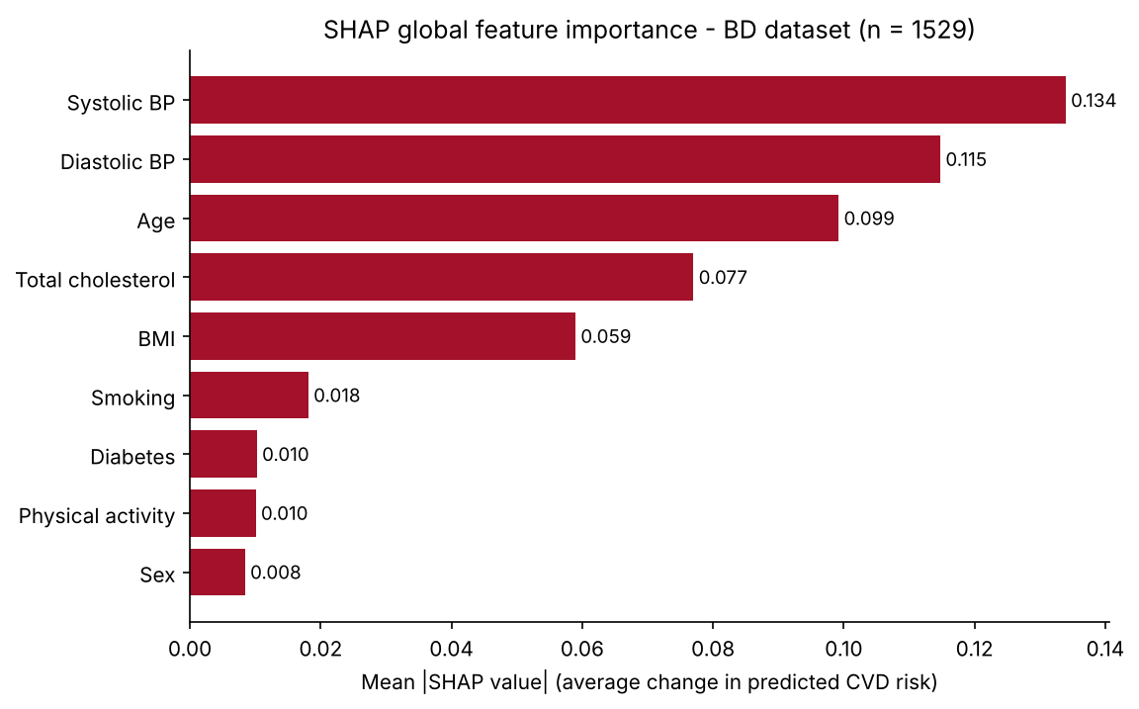
Figure 1. SHAP global feature importance, BD dataset (n = 1,529)
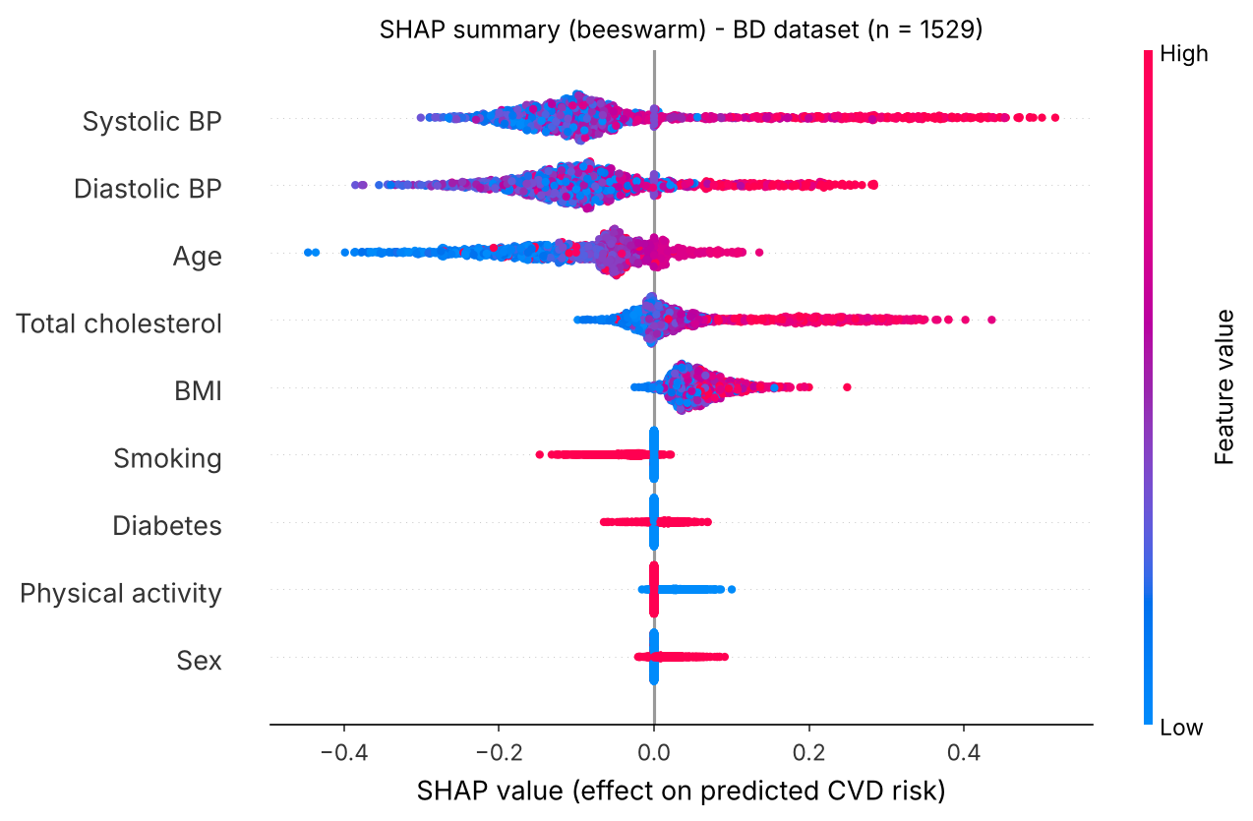
Figure 2. SHAP summary (beeswarm) plot, BD dataset
By predicted class (Figure 3). For patients predicted as CVD, the largest mean |SHAP| values were for systolic BP (0.176), diastolic BP (0.134) and total cholesterol (0.118). For patients predicted as no CVD, age had the largest effect (0.113), followed by systolic BP (0.108) and diastolic BP (0.103). Positive predictions were therefore driven mainly by blood pressure and cholesterol, and negative predictions mainly by younger age and lower blood pressure.
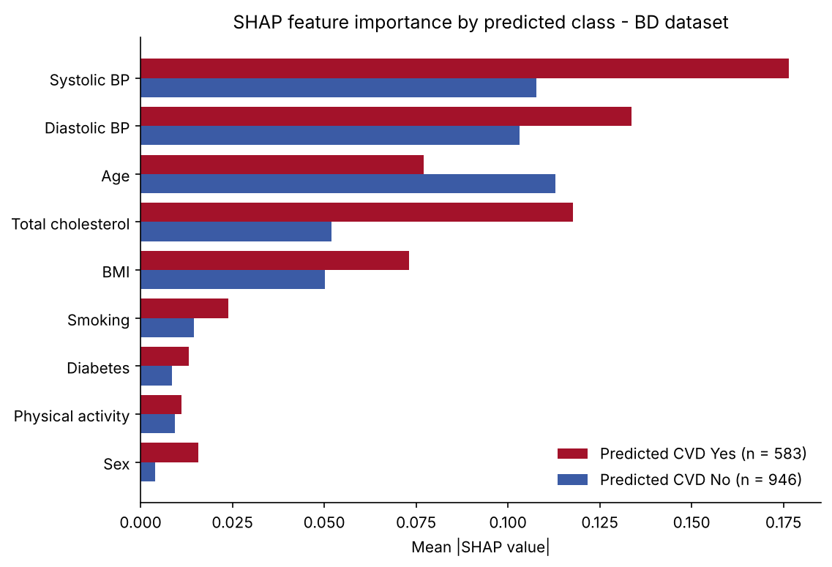
Figure 3. SHAP feature importance by predicted class, BD dataset
Most influential feature per patient (Figure 4). Taking, for each patient, the feature with the largest absolute SHAP value, systolic BP was most influential for 473 patients (30.9%), age for 459 (30.0%), diastolic BP for 361 (23.6%), total cholesterol for 200 (13.1%), BMI for 32 (2.1%) and smoking for 4 (0.3%). Section 4.5 counts the first-listed reason for the predicted class instead, which gives slightly different numbers.
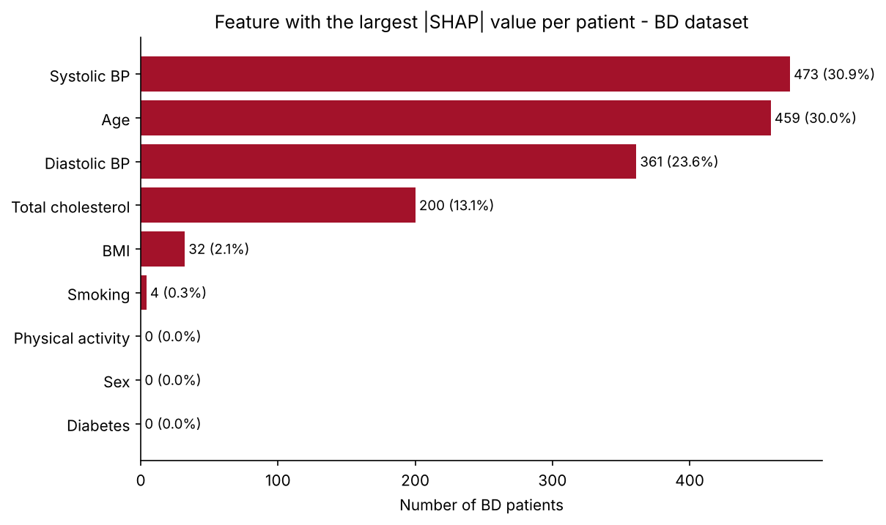
Figure 4. Feature with the largest |SHAP| value per patient, BD dataset
Shape of each effect (Figure 5).
- Systolic BP: mean SHAP −0.132 at ≤ 120 mmHg, −0.079 at 121–140, −0.012 at 141–150 and +0.282 above 150 mmHg, so predicted risk rose sharply above about 150 mmHg.
- Diastolic BP: about −0.12 up to 90 mmHg, −0.056 at 91–100 and +0.115 above 100 mmHg.
- Total cholesterol: near zero up to 200 mg/dL (−0.005), +0.045 at 201–240, +0.241 at 241–280 and +0.150 above 280 mg/dL.
- Age: SHAP rose from −0.192 (≤ 40 years) to +0.078 (61–65 years) but was negative again above 65 years (−0.097 at 66–70 and −0.078 above 70). This pattern was learned from the development data; in the BD data, the CVD rates above 65 years (26.1% at 66–70 and 30.0% above 70) were not lower than at 40 years or below (24.3%).
- Binary features: smoking lowered predicted risk (mean SHAP −0.035 for smokers), because the reference patient is a non-smoker and smokers had a lower CVD rate in the pooled development data (Section 4.3). Diabetes (+0.015), male sex (+0.016) and low physical activity (+0.031) raised it slightly. Although diabetes was associated with a 3.42-fold CVD rate in BD (Section 4.5), its SHAP effect was small.
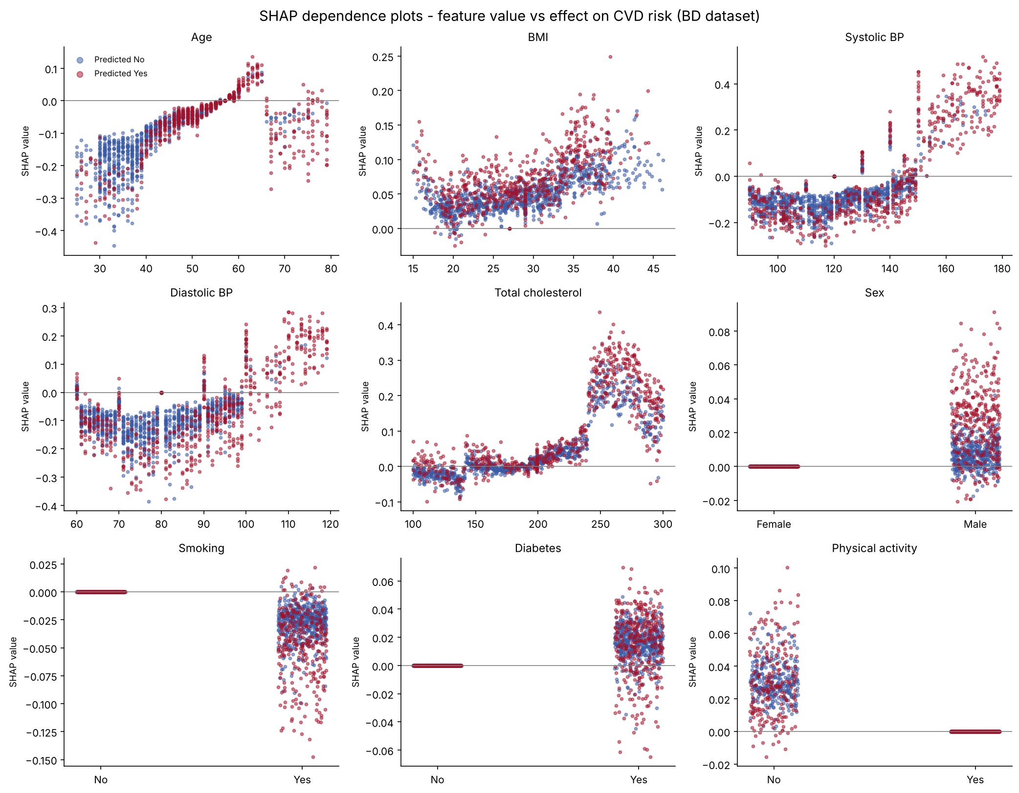
Figure 5. SHAP dependence plots: feature value against its effect on predicted risk, BD dataset
LIME (Figure 6). LIME weights were taken from the three factors per direction listed in each patient's explanation. By mean absolute weight, the leading features were age (0.064; 24.9%), systolic BP (0.063; 24.4%), sex (0.031; 12.1%) and diabetes (0.030; 11.5%), followed by diastolic BP (9.5%) and total cholesterol (8.8%). Sex, systolic BP, age and diabetes were each listed for about 80–85% of patients.
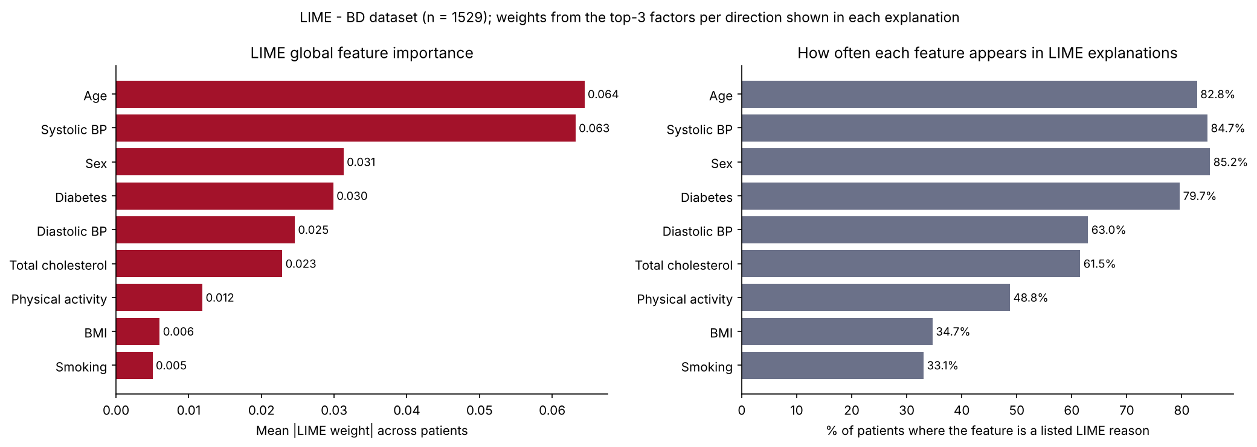
Figure 6. LIME global feature importance, BD dataset
SHAP versus LIME (Figure 7). Both methods placed systolic BP and age among the three most important features. They differed for the binary features and BMI: LIME gave sex (12.1% vs 1.6%) and diabetes (11.5% vs 1.9%) much larger shares than SHAP, and BMI a much smaller share (2.3% vs 11.1%). SHAP and LIME named the same most influential feature for 38.7% of BD patients. One possible explanation is that the two methods measure different things: SHAP gives each feature's exact contribution relative to one reference patient, whereas LIME fits a local linear approximation from perturbed samples drawn from the training data.
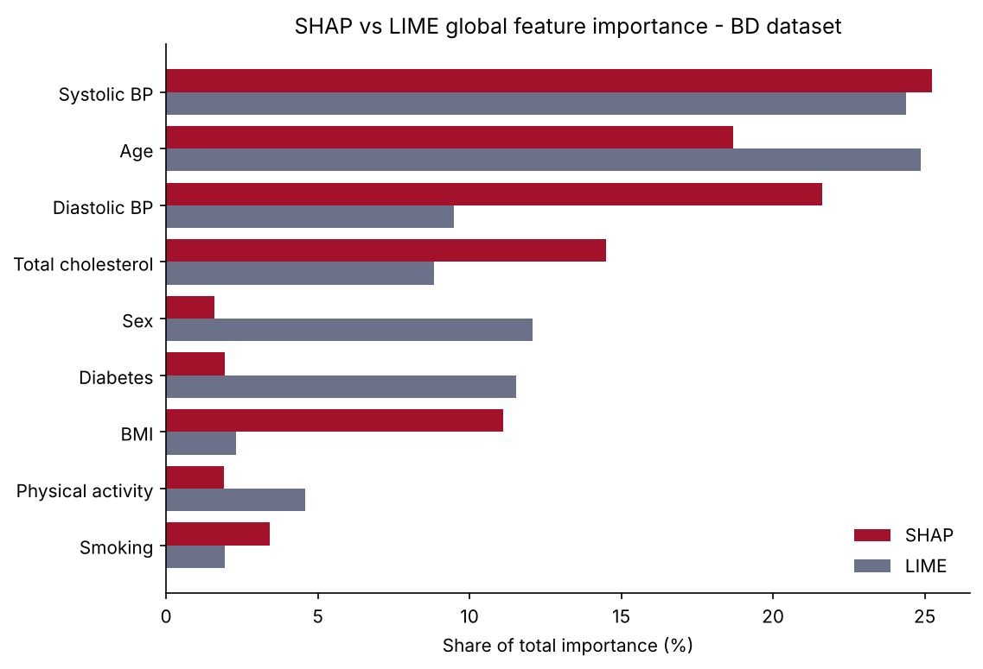
Figure 7. SHAP and LIME global importance shares, BD dataset
Example patients (Figures 8–11).
Patient | Selected as | Risk / prediction | Main SHAP reasons | Main LIME reasons
1395 | Highest risk | 89.9% / Yes | Systolic BP 162 (+0.403), diastolic BP 110 (+0.117), BMI 26.0 (+0.056); against: smoking (−0.059) | Systolic BP > 134 (+0.110), diastolic BP > 85 (+0.064), male (+0.056)
604 | Lowest risk at or above threshold | 19.14% / Yes | Cholesterol 245 (+0.212); against: systolic BP 106 (−0.179), age 43 (−0.095), diastolic BP 92 (−0.082) | Diastolic BP > 85 (+0.054), diabetes (+0.049), cholesterol > 207 (+0.044); against: age ≤ 47 (−0.101)
767 | Highest risk below threshold | 19.06% / No | Diastolic BP 78 (−0.118), systolic BP 132 (−0.086); against: BMI 16.9 (+0.071), inactive (+0.049) | Cholesterol ≤ 170 (−0.039), diastolic BP 73–80 (−0.029), no diabetes (−0.024); against: age 57–65 (+0.037)
787 | Lowest risk | 0.3% / No | Age 31 (−0.115), systolic BP 108 (−0.101), diastolic BP 71 (−0.099) | Age ≤ 47 (−0.086), systolic BP ≤ 111 (−0.049), female (−0.034)

For the clearest cases (patients 1395 and 787), SHAP and LIME gave the same leading reasons. For the two patients close to the threshold, the explanations differed: for patient 604, SHAP attributed the positive prediction mainly to a cholesterol of 245 mg/dL and treated a diastolic BP of 92 mmHg as lowering risk, whereas LIME ranked diastolic BP above 85 mmHg as the leading reason for risk. Explanations of borderline patients were therefore less consistent than those of clear cases.
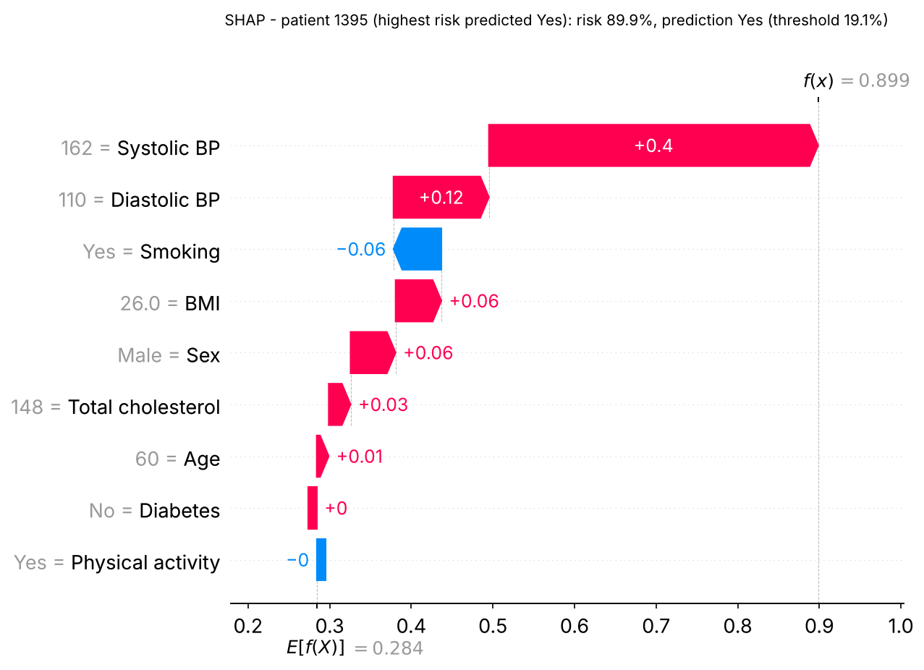 | 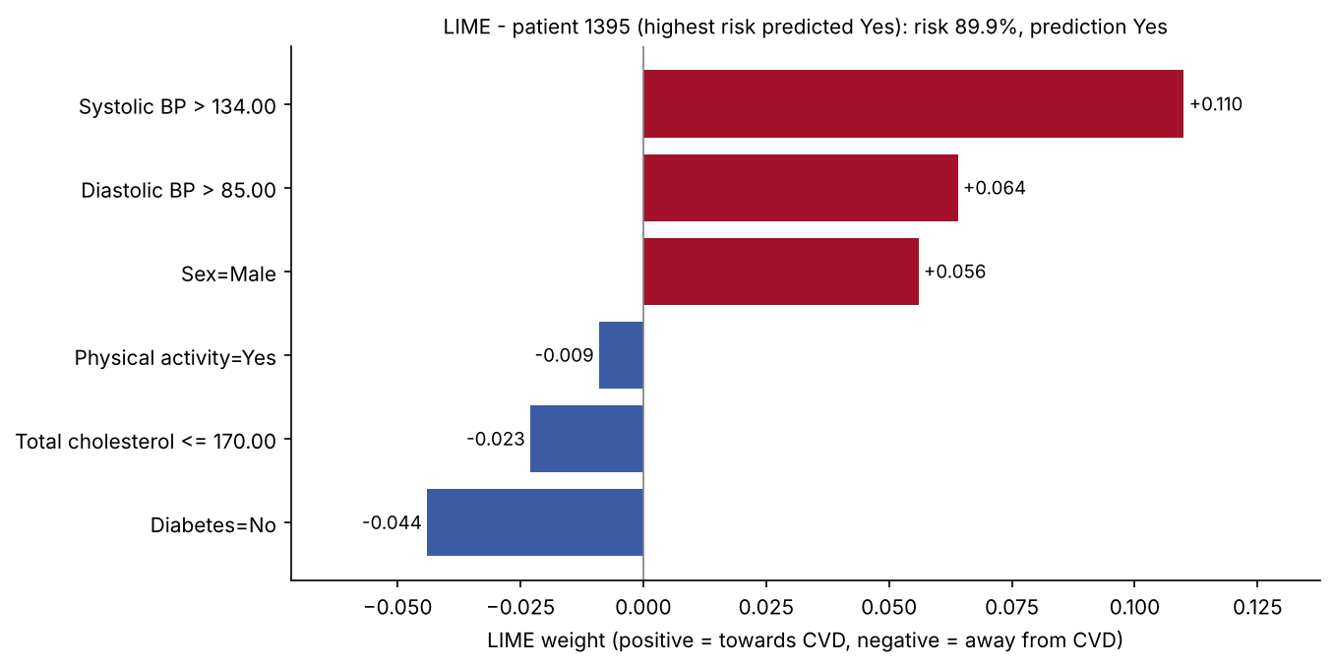
Figure 8. Patient 1395 (highest risk): SHAP waterfall (left) and LIME weights (right)
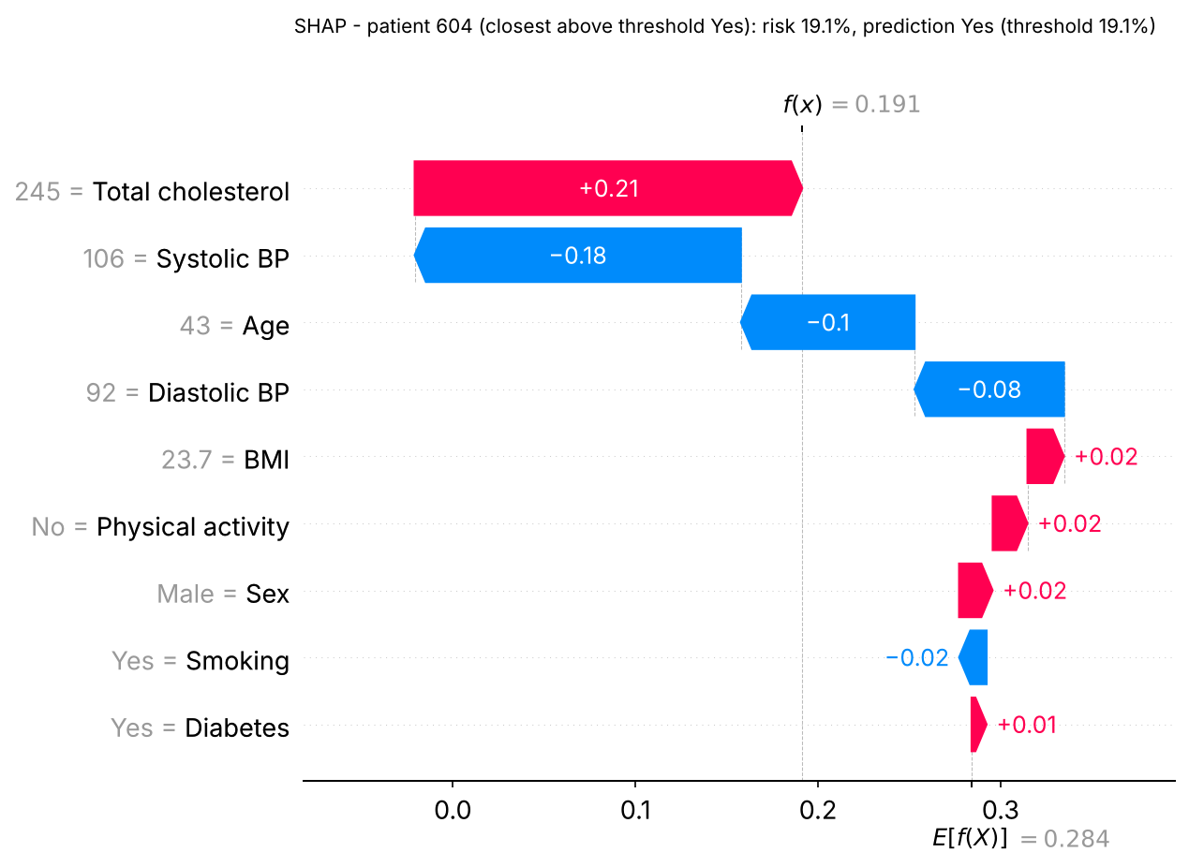 | 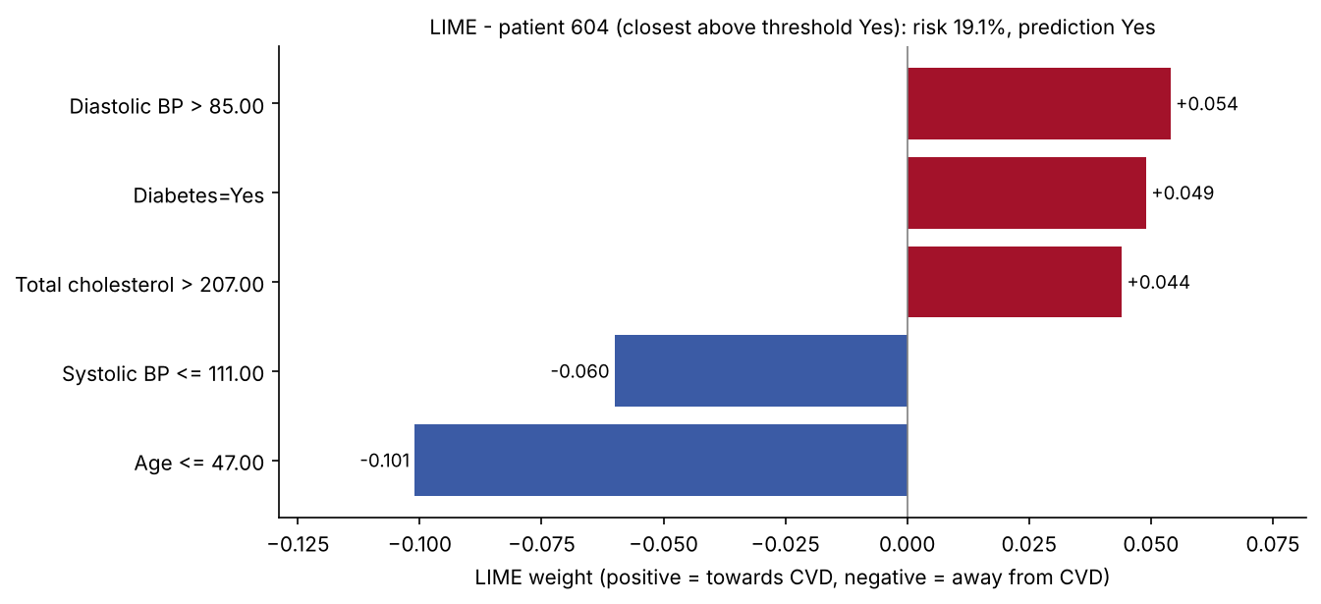
Figure 9. Patient 604 (lowest risk at or above threshold): SHAP waterfall (left) and LIME weights (right)
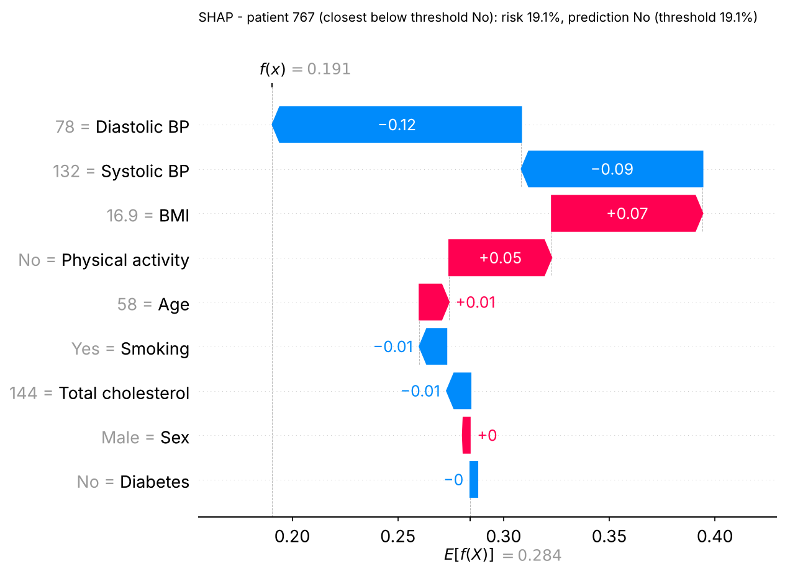 | 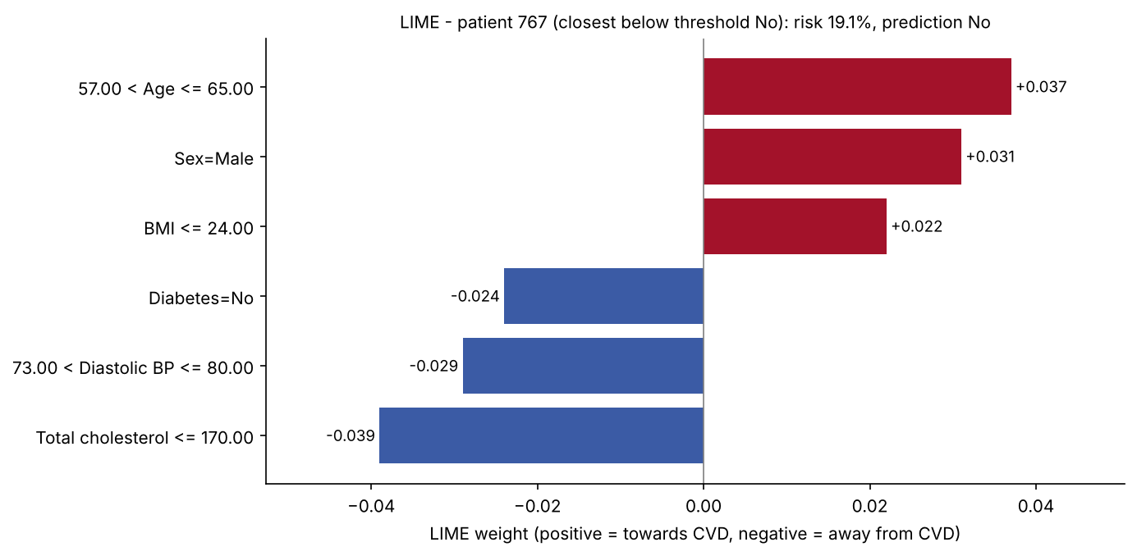
Figure 10. Patient 767 (highest risk below threshold): SHAP waterfall (left) and LIME weights (right)
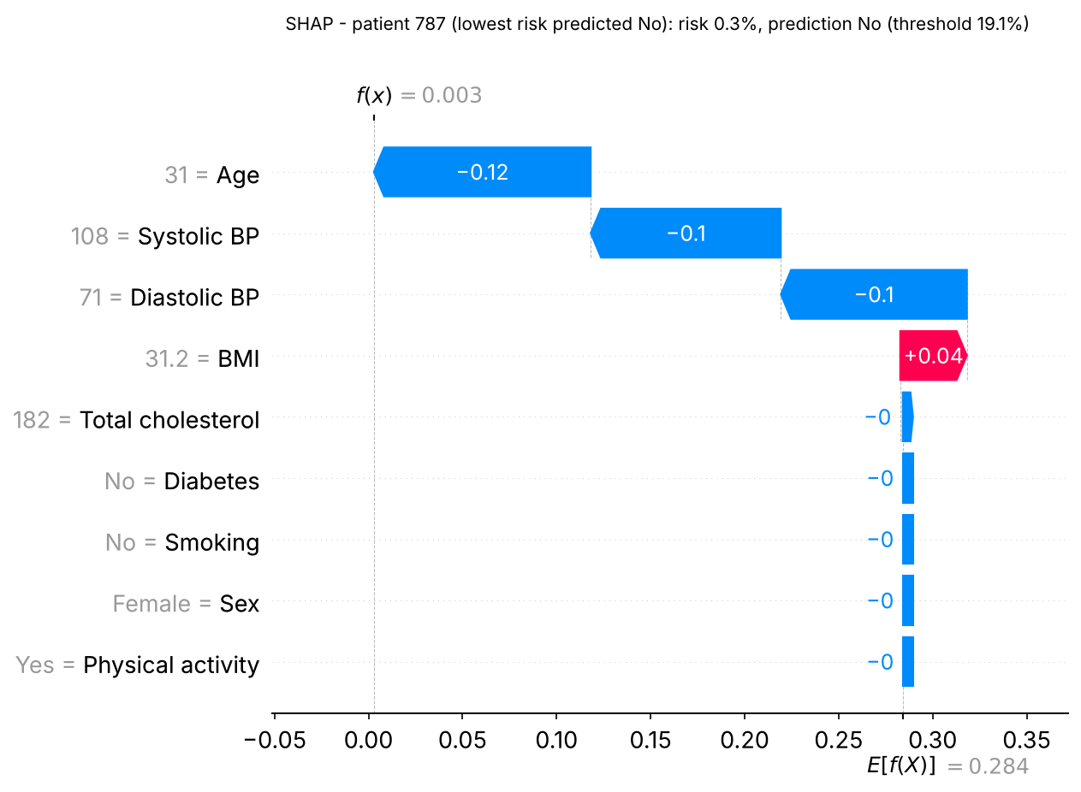 | 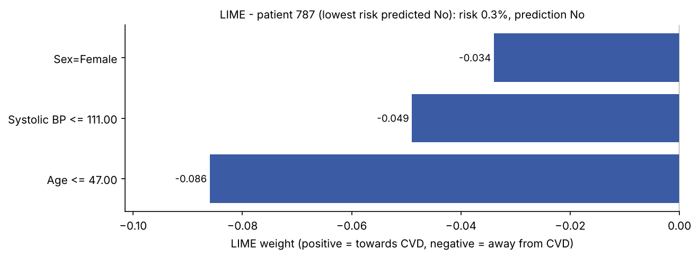
Figure 11. Patient 787 (lowest risk): SHAP waterfall (left) and LIME weights (right)

5. Results
All results use the thresholds fixed on the validation set. Development results are on the held-out test set (49,190 patients, 8,924 with CVD); external results are on the unseen BD set (1,529 patients, 385 with CVD).

5.1 Main Performance Table
Held-out test set
Model | Accuracy | Precision | Recall | F1-score
Random Forest | 0.760 | 0.414 | 0.771 | 0.538
Extra Trees | 0.750 | 0.403 | 0.786 | 0.533
XGBoost | 0.756 | 0.410 | 0.779 | 0.537
LightGBM | 0.775 | 0.431 | 0.759 | 0.550
KNN | 0.707 | 0.357 | 0.768 | 0.488
Logistic Regression | 0.629 | 0.298 | 0.770 | 0.429
Neural Network | 0.740 | 0.391 | 0.777 | 0.520
SVM | 0.757 | 0.374 | 0.505 | 0.430
Classifier Model | 0.771 | 0.426 | 0.765 | 0.548
Unseen BD set
Model | Accuracy | Precision | Recall | F1-score
Random Forest | 0.584 | 0.344 | 0.717 | 0.465
Extra Trees | 0.617 | 0.363 | 0.691 | 0.476
XGBoost | 0.690 | 0.403 | 0.483 | 0.440
LightGBM | 0.676 | 0.387 | 0.491 | 0.433
KNN | 0.547 | 0.322 | 0.722 | 0.446
Logistic Regression | 0.619 | 0.363 | 0.681 | 0.474
Neural Network | 0.530 | 0.315 | 0.735 | 0.441
SVM | 0.483 | 0.304 | 0.813 | 0.442
Classifier Model | 0.653 | 0.376 | 0.569 | 0.453
Bold marks the highest value in each column.

5.2 Secondary Performance Metrics
Held-out test set
Model | Specificity | Balanced accuracy | MCC | ROC-AUC | TP | FP | TN | FN
Random Forest | 0.758 | 0.764 | 0.431 | 0.856 | 6,876 | 9,742 | 30,524 | 2,048
Extra Trees | 0.742 | 0.764 | 0.425 | 0.852 | 7,015 | 10,404 | 29,862 | 1,909
XGBoost | 0.751 | 0.765 | 0.430 | 0.856 | 6,952 | 10,018 | 30,248 | 1,972
LightGBM | 0.778 | 0.769 | 0.444 | 0.859 | 6,772 | 8,936 | 31,330 | 2,152
KNN | 0.694 | 0.731 | 0.365 | 0.818 | 6,849 | 12,317 | 27,949 | 2,075
Logistic Regression | 0.597 | 0.684 | 0.283 | 0.745 | 6,868 | 16,214 | 24,052 | 2,056
Neural Network | 0.732 | 0.754 | 0.408 | 0.844 | 6,934 | 10,797 | 29,469 | 1,990
SVM | 0.813 | 0.659 | 0.284 | 0.710 | 4,503 | 7,540 | 32,726 | 4,421
Classifier Model | 0.772 | 0.768 | 0.442 | 0.859 | 6,827 | 9,188 | 31,078 | 2,097
Unseen BD set
Model | Specificity | Balanced accuracy | MCC | ROC-AUC | TP | FP | TN | FN
Random Forest | 0.539 | 0.628 | 0.223 | 0.688 | 276 | 527 | 617 | 109
Extra Trees | 0.593 | 0.642 | 0.246 | 0.698 | 266 | 466 | 678 | 119
XGBoost | 0.760 | 0.621 | 0.230 | 0.690 | 186 | 275 | 869 | 199
LightGBM | 0.739 | 0.615 | 0.214 | 0.680 | 189 | 299 | 845 | 196
KNN | 0.489 | 0.605 | 0.185 | 0.648 | 278 | 585 | 559 | 107
Logistic Regression | 0.599 | 0.640 | 0.243 | 0.689 | 262 | 459 | 685 | 123
Neural Network | 0.462 | 0.598 | 0.173 | 0.594 | 283 | 616 | 528 | 102
SVM | 0.372 | 0.593 | 0.172 | 0.645 | 313 | 718 | 426 | 72
Classifier Model | 0.682 | 0.625 | 0.224 | 0.671 | 219 | 364 | 780 | 166
ROC-AUC is threshold-free and reported as supporting evidence only.

5.3 Correct and Incorrect Predictions
Correct predictions = TP + TN; incorrect predictions = FP + FN.
Model | Test: correct | Test: incorrect | BD: correct | BD: incorrect
Random Forest | 37,400 | 11,790 | 893 | 636
Extra Trees | 36,877 | 12,313 | 944 | 585
XGBoost | 37,200 | 11,990 | 1,055 | 474
LightGBM | 38,102 | 11,088 | 1,034 | 495
KNN | 34,798 | 14,392 | 837 | 692
Logistic Regression | 30,920 | 18,270 | 947 | 582
Neural Network | 36,403 | 12,787 | 811 | 718
SVM | 37,229 | 11,961 | 739 | 790
Classifier Model | 37,905 | 11,285 | 999 | 530
Total predictions per model | 49,190 |  | 1,529

5.4 Model-by-Model Analysis
To make the test-set results concrete, the table below scales each model's confusion matrix to 1,000 patients, of whom about 181 have CVD.
Model | CVD found | CVD missed | False alarms | Correctly cleared
Random Forest | 140 | 42 | 198 | 621
Extra Trees | 143 | 39 | 212 | 607
XGBoost | 141 | 40 | 204 | 615
LightGBM | 138 | 44 | 182 | 637
KNN | 139 | 42 | 250 | 568
Logistic Regression | 140 | 42 | 330 | 489
Neural Network | 141 | 40 | 219 | 599
SVM | 92 | 90 | 153 | 665
Classifier Model | 139 | 43 | 187 | 632
Seven of the eight individual models and the Classifier Model found a similar number of CVD patients (138–143 per 1,000). They differed mainly in false alarms, from 182 (LightGBM) to 330 (Logistic Regression), which is what drives the spread in accuracy and precision. The SVM is the exception: it raised the fewest false alarms (153) but missed about twice as many CVD patients (90).

5.5 Classifier Model Analysis
On the test set, the Classifier Model ranked second of nine on accuracy (0.771), precision (0.426) and F1 (0.548), each within 0.005 of LightGBM, and seventh on recall (0.765). On the BD set, it ranked third on accuracy (0.653) and precision (0.376), fourth on F1 (0.453) and seventh on recall (0.569). Its ROC-AUC (0.859 test, 0.671 BD) supports the same picture. The Classifier Model matched the strongest individual model but did not exceed it on any primary metric.

5.6 Best Performance by Metric
Metric | Test set | BD set
Highest accuracy | LightGBM (0.775) | XGBoost (0.690)
Highest precision | LightGBM (0.431) | XGBoost (0.403)
Highest recall | Extra Trees (0.786) | SVM (0.813)
Highest F1-score | LightGBM (0.550) | Extra Trees (0.476)
Fewest false positives | SVM (7,540) | XGBoost (275)
Fewest false negatives | Extra Trees (1,909) | SVM (72)
No primary metric was fixed in advance for choosing a single overall model, so no universal ranking is declared. The models with the highest accuracy and precision were not those with the highest recall, and the leading models changed between the development and BD populations.

6. Research Gap
Existing research gap | How this project addresses it
Evidence on ML CVD risk models in Bangladeshi and South Asian populations is limited, despite a high and distinctive risk-factor burden (Fatema et al., 2016; Islam & Majumder, 2013; Volgman et al., 2018). | The study measured how models trained on the three development datasets transfer to 1,529 Bangladeshi patients, and analyzed the shift in population and risk relationships.
Comparisons often cover few model families, and the benefit of ML over logistic regression is inconsistent (Christodoulou et al., 2019; Krittanawong et al., 2020). | Eight model families and a stacked Classifier Model were compared under one leakage-controlled protocol, including logistic regression as the reference.
Many studies report a single summary metric, most often ROC-AUC, although precision- and recall-based measures are more informative for imbalanced outcomes (Saito & Rehmsmeier, 2015; He & Garcia, 2009). | Accuracy, precision, recall and F1-score were the primary metrics, supported by the full confusion matrix, specificity, balanced accuracy, MCC and ROC-AUC.
Explanations are often provided for a few examples or at the global level only (Rudin, 2019). | Exact SHAP and LIME explanations were generated for every BD patient and, in chunked runs, for the development records.
Merging heterogeneous datasets is common, but differences in feature representation and their effects are rarely reported. | The cholesterol and blood-pressure representation differences and a Simpson's-paradox effect on smoking are documented and analyzed.

7. Limitations
- Cholesterol and blood-pressure representation. The development files were supplied in an already-processed form, and the processing method is not documented in this record [FINAL IMPLEMENTATION DETAIL REQUIRED]. Cholesterol spread differed by source (SD 23.5 mg/dL in Dataset A, 32.3 in C, 44.3 in B and 56.4 in BD). Dataset A's cholesterol separated the outcome more strongly (single-feature ROC-AUC 0.673) than in the other sources (0.56–0.60), which could not be explained from the files.
- Dataset dominance. All records were kept without sampling or weighting, so Dataset A forms 77.4% of the development data and largely determines what the models learned. Pooling also produced a Simpson's-paradox reversal for smoking.
- Dataset shift. The BD population was younger, had more diabetes and smoking, a higher prevalence and a much weaker age–CVD gradient. Performance on BD was lower on all four primary metrics for the Classifier Model, and the reasons proposed in Section 4.5 are interpretations, not established causes.
- Class imbalance and threshold choice. With 18% prevalence, precision is structurally limited. Thresholds were chosen by Youden's J, which balances recall and specificity; a different threshold would give different accuracy, precision, recall and F1.
- Tuning objective and sampling. Hyperparameters and the ensemble method were selected by ROC-AUC, not by F1 or accuracy. Most models were tuned on stratified 20,000–60,000-row samples of the training set before being refitted on all rows.
- SVM approximation. The SVM was trained as three exact sub-models on separate thirds of the data and averaged, which is not identical to one SVM trained on all rows.
- Calibration. Mean predicted risk matched the observed rate on the test set (18.2% vs 18.1%) but not on BD (19.3% vs 25.2%), and no formal calibration analysis was performed.
- External sample size. The BD set contains 1,529 patients and 385 events. Confidence intervals were not computed, so small differences between models on BD should not be over-interpreted.
- Explainability. SHAP values were computed against a single reference patient (training medians and modes), and LIME explanations depend on random sampling. Both describe the model's behaviour, not causal effects of risk factors. SHAP and LIME named the same most influential feature for only 38.7% of BD patients, and the LIME summaries use only the three factors per direction listed in each explanation.
- Impurity measures. Gini, entropy and gain importances were computed from the training data inside the trees. They show what the models learned from the development population, which is 77% Dataset A, not how the features behave in BD data. Gain values from XGBoost and LightGBM are on different scales and were compared only as shares within each model.

8. Future Work
- Larger Bangladeshi datasets. Validate the models on larger, multi-centre Bangladeshi cohorts with documented outcome definitions, and report confidence intervals for every metric.
- Prospective validation. Follow patients forward in time to test whether the models predict future CVD events, not only current status.
- Standardised clinical measurements. Use measured cholesterol (including LDL and HDL) and blood pressure in every source, and add variables such as family history, medication use and ECG findings.
- Improved feature harmonisation. Replace imputed cholesterol and blood-pressure values with measured data where possible, document the imputation of any remaining values, and test models trained without imputed sources.
- Handling dataset dominance. Compare the all-records approach with source-balanced sampling or source weighting, and evaluate performance separately for each source.
- Calibration and recalibration. Assess calibration formally on BD data and test whether recalibrating intercept and slope on a small labelled local sample improves precision and F1.
- Threshold selection by clinical cost. Choose thresholds from explicit costs of false negatives and false positives, and tune models directly for F1 or a cost-weighted objective.
- Subgroup and fairness analysis. Report accuracy, precision, recall and F1 separately by sex, age group and diabetes status.
- Multi-country external validation. Test the same unchanged models in other South Asian and non-Western populations to separate population effects from dataset-specific effects.
- Explainability evaluation. Ask clinicians to assess whether the SHAP and LIME explanations are understandable and useful, and compare explanations across populations.

9. Conclusion
This study set out to build an explainable ML system for CVD risk classification from eight routine variables and to test, without any refitting, how well it transfers to Bangladeshi patients. Three datasets were harmonised into 327,877 development records, all of which were retained, and a Bangladeshi dataset of 1,529 patients was kept strictly unseen for final evaluation.
Eight individual models (Random Forest, Extra Trees, XGBoost, LightGBM, KNN, Logistic Regression, a Neural Network and an RBF-kernel SVM) and a ninth stacked Classifier Model were trained under a leakage-controlled protocol, with thresholds fixed on a separate validation set.
On held-out development data, LightGBM recorded the highest accuracy (0.775), precision (0.431) and F1-score (0.550), and Extra Trees the highest recall (0.786). The Classifier Model reached an accuracy of 0.771, precision of 0.426, recall of 0.765 and F1 of 0.548, matching but not exceeding the strongest individual model. Recall exceeded precision for all models except the SVM, reflecting the 18% prevalence and the screening-oriented thresholds.
On the unseen BD data, performance was lower: the Classifier Model achieved an accuracy of 0.653, precision of 0.376, recall of 0.569 and F1 of 0.453. XGBoost had the highest BD accuracy (0.690) and precision (0.403), the SVM the highest recall (0.813) and Extra Trees the highest F1 (0.476). Logistic Regression changed least between the two populations. These changes coincided with measurable differences in age, diabetes, smoking and prevalence, and with a much weaker age–CVD relationship in the BD data.
The impurity analysis showed that the tree-based models removed about 35–37% of the outcome's Gini impurity and entropy, with blood pressure contributing 56–68% of the impurity or loss reduction. In the SHAP analysis of the BD predictions, systolic BP, diastolic BP and age had the largest effects, and the younger age of BD patients lowered predicted risk on average. The association of blood pressure with CVD was similar in both populations.
The results show that models trained on the development datasets retain useful but reduced performance on Bangladeshi patients, and that external validation is needed before such tools are considered for local use. Future work should use larger, prospectively collected Bangladeshi data with measured clinical variables, documented outcome definitions, formal calibration and cost-based threshold selection. No claim is made that the system is ready for clinical deployment.

References
Alaa, A. M., Bolton, T., Di Angelantonio, E., Rudd, J. H. F., & van der Schaar, M. (2019). Cardiovascular disease risk prediction using automated machine learning: A prospective study of 423,604 UK Biobank participants. PLOS ONE, 14(5), e0213653. https://doi.org/10.1371/journal.pone.0213653
Ambale-Venkatesh, B., Yang, X., Wu, C. O., Liu, K., Hundley, W. G., McClelland, R., Gomes, A. S., Folsom, A. R., Shea, S., Guallar, E., Bluemke, D. A., & Lima, J. A. C. (2017). Cardiovascular event prediction by machine learning: The Multi-Ethnic Study of Atherosclerosis. Circulation Research, 121(9), 1092–1101. https://doi.org/10.1161/CIRCRESAHA.117.311312
Breiman, L. (2001). Random forests. Machine Learning, 45(1), 5–32. https://doi.org/10.1023/A:1010933404324
Chen, T., & Guestrin, C. (2016). XGBoost: A scalable tree boosting system. In Proceedings of the 22nd ACM SIGKDD International Conference on Knowledge Discovery and Data Mining (pp. 785–794). https://doi.org/10.1145/2939672.2939785
Chicco, D., & Jurman, G. (2020). The advantages of the Matthews correlation coefficient (MCC) over F1 score and accuracy in binary classification evaluation. BMC Genomics, 21, Article 6. https://doi.org/10.1186/s12864-019-6413-7
Christodoulou, E., Ma, J., Collins, G. S., Steyerberg, E. W., Verbakel, J. Y., & Van Calster, B. (2019). A systematic review shows no performance benefit of machine learning over logistic regression for clinical prediction models. Journal of Clinical Epidemiology, 110, 12–22. https://doi.org/10.1016/j.jclinepi.2019.02.004
Collins, G. S., Reitsma, J. B., Altman, D. G., & Moons, K. G. M. (2015). Transparent reporting of a multivariable prediction model for individual prognosis or diagnosis (TRIPOD): The TRIPOD statement. BMJ, 350, g7594. https://doi.org/10.1136/bmj.g7594
Cortes, C., & Vapnik, V. (1995). Support-vector networks. Machine Learning, 20(3), 273–297. https://doi.org/10.1007/BF00994018
Cover, T., & Hart, P. (1967). Nearest neighbor pattern classification. IEEE Transactions on Information Theory, 13(1), 21–27. https://doi.org/10.1109/TIT.1967.1053964
D'Agostino, R. B., Sr., Vasan, R. S., Pencina, M. J., Wolf, P. A., Cobain, M., Massaro, J. M., & Kannel, W. B. (2008). General cardiovascular risk profile for use in primary care: The Framingham Heart Study. Circulation, 117(6), 743–753. https://doi.org/10.1161/CIRCULATIONAHA.107.699579
Dawber, T. R., Meadors, G. F., & Moore, F. E., Jr. (1951). Epidemiological approaches to heart disease: The Framingham Study. American Journal of Public Health and the Nation's Health, 41(3), 279–286. https://doi.org/10.2105/AJPH.41.3.279
Fatema, K., Zwar, N. A., Milton, A. H., Ali, L., & Rahman, B. (2016). Prevalence of risk factors for cardiovascular diseases in Bangladesh: A systematic review and meta-analysis. PLOS ONE, 11(8), e0160180. https://doi.org/10.1371/journal.pone.0160180
Futoma, J., Simons, M., Panch, T., Doshi-Velez, F., & Celi, L. A. (2020). The myth of generalisability in clinical research and machine learning in health care. The Lancet Digital Health, 2(9), e489–e492. https://doi.org/10.1016/S2589-7500(20)30186-2
Geurts, P., Ernst, D., & Wehenkel, L. (2006). Extremely randomized trees. Machine Learning, 63(1), 3–42. https://doi.org/10.1007/s10994-006-6226-1
He, H., & Garcia, E. A. (2009). Learning from imbalanced data. IEEE Transactions on Knowledge and Data Engineering, 21(9), 1263–1284. https://doi.org/10.1109/TKDE.2008.239
Hippisley-Cox, J., Coupland, C., & Brindle, P. (2017). Development and validation of QRISK3 risk prediction algorithms to estimate future risk of cardiovascular disease: Prospective cohort study. BMJ, 357, j2099. https://doi.org/10.1136/bmj.j2099
Islam, A. K. M. M., & Majumder, A. A. S. (2013). Coronary artery disease in Bangladesh: A review. Indian Heart Journal, 65(4), 424–435. https://doi.org/10.1016/j.ihj.2013.06.004
Joshi, P., Islam, S., Pais, P., Reddy, S., Dorairaj, P., Kazmi, K., Pandey, M. R., Haque, S., Mendis, S., Rangarajan, S., & Yusuf, S. (2007). Risk factors for early myocardial infarction in South Asians compared with individuals in other countries. JAMA, 297(3), 286–294. https://doi.org/10.1001/jama.297.3.286
Kakadiaris, I. A., Vrigkas, M., Yen, A. A., Kuznetsova, T., Budoff, M., & Naghavi, M. (2018). Machine learning outperforms ACC/AHA CVD risk calculator in MESA. Journal of the American Heart Association, 7(22), e009476. https://doi.org/10.1161/JAHA.118.009476
Ke, G., Meng, Q., Finley, T., Wang, T., Chen, W., Ma, W., Ye, Q., & Liu, T.-Y. (2017). LightGBM: A highly efficient gradient boosting decision tree. In Advances in Neural Information Processing Systems 30 (pp. 3146–3154).
Krittanawong, C., Virk, H. U. H., Bangalore, S., Wang, Z., Johnson, K. W., Pinotti, R., Zhang, H., Kaplin, S., Narasimhan, B., Kitai, T., Baber, U., Halperin, J. L., & Tang, W. H. W. (2020). Machine learning prediction in cardiovascular diseases: A meta-analysis. Scientific Reports, 10, 16057. https://doi.org/10.1038/s41598-020-72685-1
Lundberg, S. M., Erion, G., Chen, H., DeGrave, A., Prutkin, J. M., Nair, B., Katz, R., Himmelfarb, J., Bansal, N., & Lee, S.-I. (2020). From local explanations to global understanding with explainable AI for trees. Nature Machine Intelligence, 2(1), 56–67. https://doi.org/10.1038/s42256-019-0138-9
Lundberg, S. M., & Lee, S.-I. (2017). A unified approach to interpreting model predictions. In Advances in Neural Information Processing Systems 30 (pp. 4765–4774).
Mohan, S., Thirumalai, C., & Srivastava, G. (2019). Effective heart disease prediction using hybrid machine learning techniques. IEEE Access, 7, 81542–81554. https://doi.org/10.1109/ACCESS.2019.2923707
Moreno-Torres, J. G., Raeder, T., Alaiz-Rodríguez, R., Chawla, N. V., & Herrera, F. (2012). A unifying view on dataset shift in classification. Pattern Recognition, 45(1), 521–530. https://doi.org/10.1016/j.patcog.2011.06.019
Pedregosa, F., Varoquaux, G., Gramfort, A., Michel, V., Thirion, B., Grisel, O., Blondel, M., Prettenhofer, P., Weiss, R., Dubourg, V., Vanderplas, J., Passos, A., Cournapeau, D., Brucher, M., Perrot, M., & Duchesnay, É. (2011). Scikit-learn: Machine learning in Python. Journal of Machine Learning Research, 12, 2825–2830.
Platt, J. C. (1999). Probabilistic outputs for support vector machines and comparisons to regularized likelihood methods. In A. J. Smola, P. Bartlett, B. Schölkopf, & D. Schuurmans (Eds.), Advances in large margin classifiers (pp. 61–74). MIT Press.
Ribeiro, M. T., Singh, S., & Guestrin, C. (2016). "Why should I trust you?": Explaining the predictions of any classifier. In Proceedings of the 22nd ACM SIGKDD International Conference on Knowledge Discovery and Data Mining (pp. 1135–1144). https://doi.org/10.1145/2939672.2939778
Roth, G. A., Mensah, G. A., Johnson, C. O., Addolorato, G., Ammirati, E., Baddour, L. M., Barengo, N. C., Beaton, A. Z., Benjamin, E. J., Benziger, C. P., et al. (2020). Global burden of cardiovascular diseases and risk factors, 1990–2019: Update from the GBD 2019 study. Journal of the American College of Cardiology, 76(25), 2982–3021. https://doi.org/10.1016/j.jacc.2020.11.010
Rudin, C. (2019). Stop explaining black box machine learning models for high stakes decisions and use interpretable models instead. Nature Machine Intelligence, 1(5), 206–215. https://doi.org/10.1038/s42256-019-0048-x
Rumelhart, D. E., Hinton, G. E., & Williams, R. J. (1986). Learning representations by back-propagating errors. Nature, 323(6088), 533–536. https://doi.org/10.1038/323533a0
Saito, T., & Rehmsmeier, M. (2015). The precision-recall plot is more informative than the ROC plot when evaluating binary classifiers on imbalanced datasets. PLOS ONE, 10(3), e0118432. https://doi.org/10.1371/journal.pone.0118432
Steyerberg, E. W., & Vergouwe, Y. (2014). Towards better clinical prediction models: Seven steps for development and an ABCD for validation. European Heart Journal, 35(29), 1925–1931. https://doi.org/10.1093/eurheartj/ehu207
Van Calster, B., McLernon, D. J., van Smeden, M., Wynants, L., & Steyerberg, E. W. (2019). Calibration: The Achilles heel of predictive analytics. BMC Medicine, 17, Article 230. https://doi.org/10.1186/s12916-019-1466-7
Volgman, A. S., Palaniappan, L. S., Aggarwal, N. T., Gupta, M., Khandelwal, A., Krishnan, A. V., Lichtman, J. H., Mehta, L. S., Patel, H. N., Shah, K. S., Shah, S. H., & Watson, K. E. (2018). Atherosclerotic cardiovascular disease in South Asians in the United States: Epidemiology, risk factors, and treatments: A scientific statement from the American Heart Association. Circulation, 138(1), e1–e34. https://doi.org/10.1161/CIR.0000000000000580
Weng, S. F., Reps, J., Kai, J., Garibaldi, J. M., & Qureshi, N. (2017). Can machine-learning improve cardiovascular risk prediction using routine clinical data? PLOS ONE, 12(4), e0174944. https://doi.org/10.1371/journal.pone.0174944
WHO CVD Risk Chart Working Group. (2019). World Health Organization cardiovascular disease risk charts: Revised models to estimate risk in 21 global regions. The Lancet Global Health, 7(10), e1332–e1345. https://doi.org/10.1016/S2214-109X(19)30318-3
Wolpert, D. H. (1992). Stacked generalization. Neural Networks, 5(2), 241–259. https://doi.org/10.1016/S0893-6080(05)80023-1
Youden, W. J. (1950). Index for rating diagnostic tests. Cancer, 3(1), 32–35.
Yusuf, S., Hawken, S., Ôunpuu, S., Dans, T., Avezum, A., Lanas, F., McQueen, M., Budaj, A., Pais, P., Varigos, J., & Lisheng, L. (2004). Effect of potentially modifiable risk factors associated with myocardial infarction in 52 countries (the INTERHEART study): Case-control study. The Lancet, 364(9438), 937–952. https://doi.org/10.1016/S0140-6736(04)17018-9
Dataset sources. The sources of Datasets A, B and C and of the BD_2025 dataset should be cited according to their providers' instructions: [DATA REQUIRED].

